AUA Working Paper Series No. 2020-2
September 9, 2020

Bribing to Queue-Jump: An experiment on cultural differences in bribing attitudes among Greeks and Germans

Andreas C. Drichoutis
Agricultural University of Athens
adrihout@aua.gr

Veronika Grimm
University of Erlangen-Nuremberg
veronika.grimm@fau.de

Alexandros Karakostas
University of Queensland
alexandros.karakostas@uq.edu.au

This series contains preliminary manuscripts which are not (yet) published in academic journals
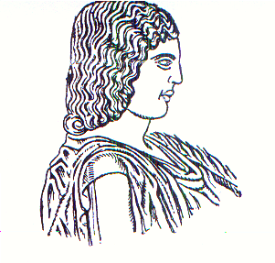
Agricultural University of Athens ∙
Department of Agricultural Economics
& Rural Development ∙ http://www.aoa.aua.gr

