AUA Working Paper Series No. 2020 - 1

A goal-framing approach to green payments’ efficiency when vertical integration is an option

Giorgos N. Diakoulakis, PhD candidate

Department of Agricultural Economics and Rural Development, Agricultural University of Athens, Iera Odo 75, 11852, Athens, Greece

Email: di_gi@aua.gr

Athanasios Kampas, Associate Professor

Department of Agricultural Economics and Rural Development, Agricultural University of Athens, Iera Odo 75, 11852, Athens, Greece

Email: tkampas@aua.gr

This series contains preliminary manuscripts which are not (yet) published in professional journals
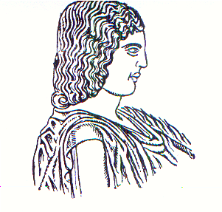
Agricultural University of Athens ∙
Department of Agricultural Economics
& Rural Development ∙ http://www.aoa.aua.gr

