AUA Working Paper Series No. 2018-1
March 2018

Loss Aversion, Expectations and Anchoring in the BDM
Mechanism

Achilleas Vassilopoulos
1ICRE8: International Centre for Research on the Environment and the Economy
avas@aua.gr

Andreas C. Drichoutis
Department of Agricultural Economics & Rural Development, Agricultural University of Athens
adrihout@aua.gr

Rodolfo M. Nayga
Department of Agricultural Economics & Agribusiness, University of Arkansas
rnayga@uark.edu

This series contains preliminary manuscripts which are not (yet) published in professional journals
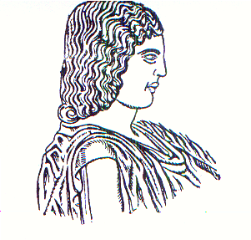
Agricultural University of Athens ∙
Department of Agricultural Economics
& Rural Development ∙ http://www.aoa.aua.gr

