AUA Working Paper Series No. 2017-3
September 2017

Cognitive Ability and Bidding Behavior in Second Price Auctions: An Experimental Study

Ji Yong Lee^{*1}, Rodolfo M. Nayga, Jr^{.†1,2}, Cary Deck^{‡3,4}, and Andreas Drichoutis^{§5}

¹University of Arkansas
²The National Bureau of Economic Research
³University of Alabama
⁴Chapman University
⁵Agricultural University of Athens

* Corresponding author: Research Associate, Department of Agricultural Economics and Agribusiness, 217 Agriculture Building, University of Arkansas, Fayetteville, AR 72701, USA, email: jyl003@uark.edu
† Distinguished Professor, Department of Agricultural Economics and Agribusiness, 217 Agriculture Building, University of Arkansas, Fayetteville, AR 72701, USA and The National Bureau of Economic Research, email: rnayga@uark.edu
‡ Professor, Department of Economics, Finance, and Legal Studies, 200 Alston Hall, University of Alabama, Tuscaloosa, AL 35487, USA and Economic Science Institute, One University Drive, Chapman University, Orange, CA 92866, USA, email: cdeck@cba.ua.edu
§ Assistant Professor, Department of Agricultural Economics & Rural Development, Agricultural University of Athens, Iera Odos 75, 11855, Greece, e-mail: adrihout@aua.gr

This series contains preliminary manuscripts which are not (yet) published in professional journals
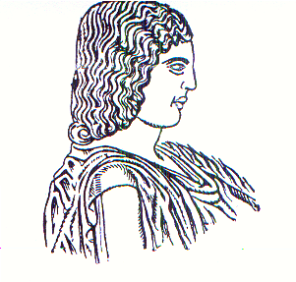
Agricultural University of Athens ∙
Department of Agricultural Economics
& Rural Development ∙ http://www.aoa.aua.gr

