AUA Working Paper Series No. 2017-2
September 2017

Economic rationality under cognitive load

Andreas Drichoutis
Assistant Professor, Department of Agricultural Economics & Rural Development, Agricultural University of Athens, Iera Odos 75, 11855, Greece,
adrihout@aua.gr.

Rodolfo M. Nayga, Jr.
Distinguished Professor and Tyson Endowed Chair, Department of Agricultural Economics & Agribusiness,
University of Arkansas, Fayetteville, AR 72701, USA, and Adjunct Professor, Norwegian Institute of Bioeconomy
Research, and NBER, tel:+1-4795752299
rnayga@uark.edu.

This series contains preliminary manuscripts which are not (yet) published in professional journals
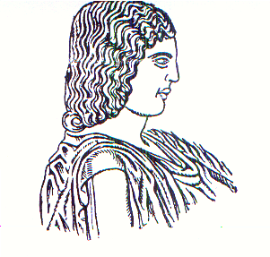
Agricultural University of Athens ∙
Department of Agricultural Economics
& Rural Development ∙ http://www.aoa.aua.gr

