AUA Working Paper Series No. 2017-1
August 2017

Small farms’ contribution to food security: a food system resilience perspective

Pavlos Karanikolas
Agricultural University of Athens (AUA), Greece, Dept. Agr. Economics and Rural Development, Assistant Professor, pkaranik@aua.gr

Dimitrios Theocharidis
Greek Payment Authority of Common Agricultural Policy Aid Schemes, dtheocha@hotmail.com

Thedoros Tsiligiridis
Agricultural University of Athens (AUA), Greece, Dept. Agr. Economics and Rural Development, Professor, tsili@aua.gr

Konstantinos Tsiboukas
Agricultural University of Athens (AUA), Greece, Dept. Agr. Economics and Rural Development, Professor, tsiboukas@aua.gr

This series contains preliminary manuscripts which are not (yet) published in professional journals
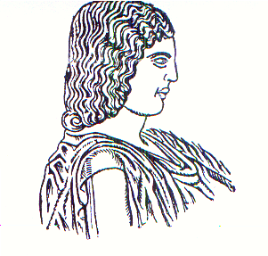
Agricultural University of Athens ∙
Department of Agricultural Economics
& Rural Development ∙ http://www.aoa.aua.gr

