AUA Working Paper Series No. 2016-3
September 2016

Intertemporal stability of survey-based measures of risk
and time preferences over a three-year course

Andreas C. Drichoutis
Assistant Professor, Department of Agricultural Economics & Rural Development, Agricultural University of Athens
adrichout@aua.gr

Achilleas Vassilopoulos
Senior Researcher, ICRE8: International Center for Research on the Environment and the Economy
as@aua.gr, achilleas.vassilopoulos@icre8.eu.

This series contains preliminary manuscripts which are not (yet) published in professional journals
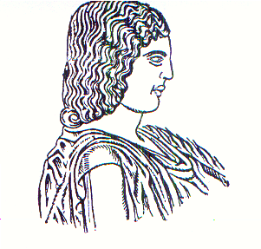
Agricultural University of Athens ∙
Department of Agricultural Economics
& Rural Development ∙ http://www.aoa.aua.gr

