Impact assessment of agricultural and fiscal policy in Greece on business-oriented arable farms

Stamatis Mantziaris (sta.athens@hotmail.com)
Postgraduate Program MBA in Agribusiness, Agricultural University of Athens

Stelios Rozakis (srozakis@isc.tuc.gr)
Environmental Engineering Department, Technical University of Crete

ABSTRACT
This paper examines the impacts of the national implementation of the CAP reform 2014-20 and the fiscal policy derived from the Third Memorandum on the crop-mix decisions and the viability of business oriented Greek arable farming. A mathematical programming model is specified maximizing farmers' utility subject to agronomic, institutional and resource constraints. According to CAP reform scenario, reduction for cotton and durum wheat and on the other hand increase mainly for set aside and secondary for alfalfa cultivation areas is observed. Similar crop-mix is cultivated for the combined scenario of CAP and fiscal reform. Although gross margin decreases in both scenarios, almost all farms remain viable because 64% of their gross revenue is derived from the market. Consequently, farms are not sensitive enough in reform concerning reduction of subsidies but the combination with tax measures decrease the levels of viability significantly.

Key words: Utility function, mathematical programming, policy analysis, arable farming, Thessaly
JEl codes: C61, Q12, Q18

- Introduction
On 26 June of 2013, the European Commission , the European Council and the European Parliament came to political agreement concerning Common Agricultural Policy(CAP) reform 2014-20. Major aims of new CAP scheme is the redistribution of direct payments among EU members and among regions of each EU member. Additionally, the CAP reform aims to improve environmental performance of agriculture. The Greek government opted for the partial convergence of single farm payment in progress since 2015-2016 cultivating period and fully implemented in the horizon of 2019. Moreover, Greek farmers are faced with the Third memorandum fiscal measures, namely an increase of tax rate and the abolishment of tax allowance for diesel oil.
A significant number of various studies has been undertaken, concerning the impact assessment of CAP reform 2014-20 (Cimino et al.,2015; Donati et al., 2015 ; Solazoo et al., 2014) . Concerning analytical tools, a very common methodology for policy analysis in agriculture is the use of variants of mathematical programming. Focusing on Greek agriculture, a variety of mathematical programming sector models has been used in order to be assessed the impacts of CAP reform 2003, mainly for tobacco and cotton sector. An indicative list of sector mathematical programming models contains linear programming (Mattas et al., 2006) ,positive models incorporating downward sloping demand (Rozakis et al., 2008), multi-criteria methods with non-interactive elicitation of the utility function (Manos et al. 2009) or increasing cost functions by means of Positive Mathematical Programming (PMP) in Petsakos & Rozakis (2015) and Rozakis (2011) .
.
In this paper, we assess the impacts of the latest CAP reform , namely the impacts of decoupled payments partial convergence in combination with greening requirements for the purpose of crop diversification, and the Third Memorandum tax measures in a sample of arable farms of Karditsa Prefecture. The sample farms are considered business oriented for Greek standards since they characterized by relatively large economic size and almost the 64% of their gross revenue is derived from market. For the purpose of policy analysis we use multi-criteria mathematical programming with individual utility function elicited from observed decisions at the farm level. The decision criteria are gross magin maximization , family labor maximization and working capital minimization. A significant addition , is that model taking in consideration the agri –environmental payments and constraints in the context of second pillar of CAP .
Then, we modify the parameters and constraints according to new CAP scheme and Third Memorandum tax measures in order to assess the impacts in crop mix and viability of farms. We consider that the results of analysis can be useful , since could be representative to some degree , for similar business oriented arable farms of Thessaly ,Central Greece, and Central Macedonia.
This paper is organized in five sections , namely section two describes the model specification of baseline and the theoretical framework of multi-criteria mathematical programming methodology , section three contains the 1)sample description , 2) the validation of model which is intended for policy analysis and 3) the model specification of scenarios .Section four analyses the impacts of CAP and taxation reform in crop mix and viability of farms. In section five are articulated some conclusions.

2.Methodology
2.1 Model specification -Baseline (CAP 2007-13)
A bottom-up staircase model based on individual farm data is specified for arable agriculture to simulate supply. A modular structure allows for taking into account the diversity of the arable farm system and production technology at a large extent independent of time-series data thus appropriate for policy analysis in cases of substantial policy reforms (Rozakis and Sourie, 2001). Each sub model consists of multiple objective functions and a number of resource, institutional and agronomic constraints. More specifically, different objective functions correspond to different goals of farmers. The first goal is the gross margin maximization, considering that a business-oriented farm attempt to optimize its economic result.
Although the business-oriented type of farms, family labor covers almost 30% of total labor requirements. Thus, we assume that farmers attempt to maximize family labor through their crop mix decision. As third goal, we consider the working capital minimization, assuming that farmers attempt to minimize their variable expenses since they can receive decoupled payment by keeping arable land (set-aside included) equal to land entitlements. At this point, it must be underlined that in literature review an additional criterion which corresponds to the minimization of risk is observed (Petsakos et al., 2009; Amador et al., 1998). However, the specific criterion is not studied in this paper because assuming that the expectations of the Greek farms about unknown values of parameters (e.g. prices of non-contracted crops, crop yields) are based in the most recent experience. More specifically, in case of non-contracted crops(e.g. cotton, maize, alfalfa, durum wheat) the value of expected price is considered the received price of t-1 period. Concerning crop yields , farmers consider that generally are not observed significant deviations , thus the data yields of a few previous years ,could be used to calculate a representative expected yield .
Constraints are enrolled in three different categories, namely in resources constraints, First Pillar policy constraints and Second Pillar policy constraints. Resources constraints correspond to total land, irrigated land, family labor and working capital availability of each farm. First Pillar policy constraints include the land entitlements activation in order to be received the decoupled payment. Concerning cross compliance obligations (20% cultivation of land entitlements with legumes or cultivation of three different crops), are ignored by farmers.
The above two categories of constraints are included in all sub-models .Second Pillar policy constraints include the optional obligations of agri-environmental measures, namely nitrogen pollution reduction program (A or B methodology) and organic farming, in order to be received the agri-environmental subsidy.
2.2 Initial set of goals & model constraints
All crops cultivated in a sample are treated as alternative activities for every farm in the sample.For crops not present in a production plan, are used the average data of sample concerning yield and family labor. As regards the crop cost prediction, in case of agricultural inputs(e.g. fertilizers) and labor cost is used the average cost of the sample and in case of mechanical operations costs , is taken into consideration the machinery level of farm in order to estimate the possible rent rate of machinery and fuel costs with precision.
.The goals and constraints used in this analysis and their mathematical expressions are given below (see the appendix 1 for the indices, parameters and decision variables)
1.Maximization of gross margin (in euros)
f(1)= Max[(lg_land * pay) + (lg_organic * orgpay) + (lg_nitro_A * nitropay_A) + (lg_nitro_B * nitropay_B) +] (1)

2.Maximization of family labor (in hours)

f(2)= Max [ ] (2)

3. Minimization of working capital (in euros)

f(3)=Min [ ] (3)
Resources constraints
4.Available arable land :
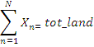 (4)

The sum of cropping area equal to total land .

5.Available irrigated land:
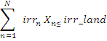 (5)
The sum of irrigated crops area cannot exceed of the available irrigated land.
6.Available working capital:
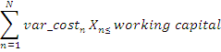(6)
The sum of variable cost per crop cannot exceed of the available working capital.
7.Available family labor:
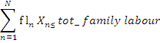 (7)

The sum of family labor per crop cannot exceed of the available family labor.
Policy constraints-First pillar
8.Land entitlements activation:
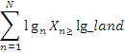 (8)
The sum of eligible crops area must be at least equal to land entitlements area .

Policy constraints-Second pillar
9.Nitrogen pollution reduction program – Methodology A:

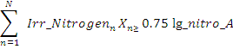
(9)
The sum of eligible crops area for irrigated rotation must be at least equal to 75% of land entitlements of nitrogen reduction pollution program for methodology A.

(10)
The set aside area must be at least equal to 25% of land entitlements of nitrogen reduction pollution program for methodology A.

10. Nitrogen pollution reduction program – Methodology B:

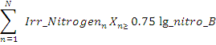
(11)
The sum of eligible crops area for irrigated rotation must be at least equal to 75% of land entitlements of nitrogen reduction pollution program for methodology B.

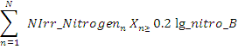
(12)
The sum of eligible crops area for non- irrigated rotation must be at least equal to 20% of land entitlements of nitrogen reduction pollution program for methodology B.

_B (13)
The set aside area must be at least equal to 5% of land entitlements of nitrogen reduction pollution program for methodology B.

11.Organic farming program:
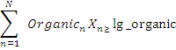 (14)
The sum of eligible crops area for organic farming must be at least equal to land entitlements of organic farming program.

2.3 Multi-criteria mathematical programming in exploring the decision making criteria of a farm
The traditionally used decision making criterion in farm-based mathematical programming models corresponds to maximization of gross margin, assuming that farmers allocate available area to the various cropsso that to optimize the economic objective. Though there is evidence that farmers take into consideration more than one decision criteria when they are plan the crop mix of following year , giving a different weight to each criterion .
In order to elicit the weights of decision making criteria, we apply a non-interactive method that is based on weighted goal programming and has been used for the utility function assessment of large farms in Spain (Amador et al.,1998). In case of Greek farming, this methodology has been applied for evaluating alternatives of tobacco cultivation under the EU common agricultural policy (Manos et al., 2009) ,for estimating milk supply from sheep farms (Sintori et al., 2010) and for the elicitation of tree farmers’ goals(Karanikolas et al.,2013). In order to present the steps of methodology, we use the description below that has been used in Karanikolas et al. (2013).
The first step on this method is to define a tentative set of aims and to create the pay-off matrix by consecutive optimizations of the classical mathematical programming decision model of the farm for each one of the above objectives. The pay-off matrix elements and the observed values of the objectives are used to form a system of q equations that when solved will give us the weights of the individual objectives.
$\sum_{j=1}^{q}{wjf\text{ij}=fi}$$i=1,2,\text{.}\text{.}\text{.},q$ (15)
where
$$\sum_{j=1}^{q}{wj}=1$$
where$wj$ the weight measuring the relative importance attached to the i-th objective, $f\text{ij}$the value achieved by the i-th objective when the j-th objective is optimized and $f_{i}$ the observed value achieved by the i-th objective.
Usually an exact non-negative solution to the above system of equations does not exist and the optimal solution is approximated with the distance metric (L metric) so as to minimize the deviation of the solution from the observed values. In a general form by combining metrics L1 and L∞, the solution can be derived from a linear programming mathematical model (Amador et al., 1998).
$\text{MinD}+λ\sum_{i=1}^{q}{(\frac{n_{i}+p_{i}}{f_{i}}})$ (16)
subject to the following constraints:
$\sum_{j=1}^{q}{wjf\text{ij}+ni−pi=fi}$$i=1,2,\text{.}\text{.}\text{.},q$ (17)
$\sum_{j=1}^{q}{w_{j}f_{i_{j}}+f_{i}D≥f_{i}}$ (18)
$−\sum_{j=1}^{q}{w_{j}f_{i_{j}}+f_{i}D≥−f_{i}}$ (19)
$\sum_{j=1}^{q}{w_{j}=1}$ (20)
Apart from the weights (w), the model comprises the following variables: the negative deviation, i.e. the under-achievement of the i-th objective with respect to a given target (, the positive deviation i.e. the over-achievement of the i-th objective with respect to a given target (, the maximum deviation of i-th objective with respect to a given target (D). The parameter is measuring the substitution rate between the various objectives in the utility function.
The derived weights can be employed to determine the farmer's utility function, which has the following form:
$u=−\text{Max}\left\{\frac{w_{i}}{k_{i}}\left[f_{i}^{}−f_{i}(x)\right]\right\}+λ\sum_{j}^{q}{\frac{w_{i}}{k_{i}}f_{i}(x)}$ (21)
where is a normalizing factor that is activated when the various goals are measured in different units. A range of utility functions can be derived from (21), depending on the λ value. If λ=0 then the utility function becomes a Tchebycheff function , implying a complementarity relation between the different objectives. In that case only the maximum deviation is minimized subject to the (18),(19) and (20) constraints. If λ is large enough, an additive and separable utility function dominates. According to (16) the sum of the positive and negative deviation is minimized subject to (17) and (20) constraints. For small values of λ the utility function identifies to an augmented Tchebycheff function.
The next step is to verify the model, i.e. to measure how accurately the objective function can reproduce the farmer's decision making. We solve the (Amador et al., 1998):
$\text{MinD}−λ\sum_{i=1}^{q}{\frac{wi}{ki}}fi(x)$ (22)
subject to constraints (17)-(20)

x$∈$F feasible area where the X belong to defined by the set of resource, institutional and agronomic constraints.

For determining the final functional form of the farmer's utility function, the results of the minimization of (22) for various levels of λ, are compared to the observations of the objectives and the closest value is selected thus resulting in a utility function form.
3. Case study
3.1. Data
Sample characteristics
Surveyed farms are located in the plain of Regional unit of Karditsa which is considered one of the most important arable farming regions of Greece. The Karditsa plain covers 22% of Thessaly’s region farmland, a fact that places it second, in terms of size, among the four regional units of Thessaly (Region of Thessaly, 2011).
Farm data concerning years 2005 and 2006, are derived from the database of research project PILOTEC. Updated farm data, concerning year 2012, were collected in the context of MSc thesis through personal interviews (Mantziaris, 2013), and correspond to 48 farms(out of 70 initially surveyed in period 2005-06), specialising in arable farming. The most important crop for the period 2005-12, in terms of land coverage, is cotton (see also table 1) .
Up until 2005, tobacco (Virginia variety) held the lion’s share in terms of revenue stream cultivated at a significant percentage of total land (19,2%). In the following year, tobacco cultivation was abandoned due to full decoupling of subsidies triggered by the CAP 2003 reform. This, can be explained by the low farm gate market price of tobacco (0,3 euros/kg), compared to variable cost (almost 1 euros/kg, see also table 3).
According to 2012 data , tobacco cultivation is observed at 6.7% of total land because of farm gate price (2 euros/kg) that had increased since 2010. At this point, we would like to mention that all tobacco farmers have replaced the diesel boilers of drying kiln with biomass boilers due to the high cost of diesel oil.
Another major evolution for the period 2005-12, is the considerable increase of alfalfa cultivation due to the partial and full decoupling of subsidies for cotton and maize respectively. Consequently, alfalfa cultivation becomes more competitive since is characterized by similar variable cost to cotton and maize (see also table 3).
Τhe increase of set-aside is mainly due to the fact that a significant number of farmers participate in the nitrogen reduction agri-environmental program in the context of Second Pillar of CAP for the 2007-13 programming period. Participants are obligated to keep a percentage of irrigated arable land in set-aside.

Table 1
Crop patterns in the sample farms (2005-2012)
Year |  | 2005 |  |  | 2006 |  |  | 2012
Crop | Area (Ha) | % of area | % of farms | Area (Ha) | % of area | % of farms | Area (Ha) | % of area | % of farms
Cotton (irrigated) | 337.4 | 55.9 | 96 | 371.7 | 61.8 | 96 | 467.9 | 55.2 | 85
Tobacco (irrigated) | 115.7 | 19.2 | 100 | 2. 5 | 0.4 | 4 | 58.6 | 6.7 | 25
Maize (irrigated) | 44.7 | 7.4 | 30 | 40.5 | 6.7 | 26 | 27 | 3.1 | 29
Processed Tomato (irrigated) | 26. 6 | 4.4 | 6 | 24.1 | 4.0 | 8 | 31 | 3.6 | 4
Processed Pepper (irrigated) | 3.7 | 0.6 | 12 | 9.6 | 1.6 | 12 | 30 | 3.5 | 19
Alfalfa (irrigated) | 5.0 | 0.8 | 4 | 7.8 | 1.3 | 6 | 66.5 | 7.8 | 23
Durum Wheat (non-irrigated) | 68.5 | 11.4 | 34 | 119.6 | 19.9 | 60 | 142 | 16.7 | 75
Set-aside (non-irrigated) | 1.8 | 0.3 | 2 | 25.3 | 4.2 | 18 | 27.2 | 3.2 | 33
Total | 603.5 | 100 | 100 | 601.2 | 100 | 100 | 847.2 | 100 | 100

Focusing on the most recent data (2012) , the irrigated land covers approximately 80% of total land a relatively high percentage, considering that lower than 50% of agricultural fields are irrigated at the country level. The average farm in the sample cultivates 17.65 ha an area almost double in size compared to 7.2 ha of the average farm in Greece and also when considering that 89% of the farms in Greece are, in utilised agricultural areas (UAA) terms, equal or smaller than 10 ha (European Commission, 2015) (see also table 2) Apparently, the sample farms can be considered as adaptable and viable in the context of CAP 2003 reform, since their total land has been enlarged significantly for the period 2005-12 . Taking into consideration that the initial total land of sample was almost 810 hectares, we assume that the active farms for 2012, enlarge their size from 603,5 hectares to 847, mainly because they incorporate the abandoned land of the farms that we could not update data because they went out of business for reasons described above. Additionally, the specific farms cultivated mainly cotton and durum wheat . According to active sample farmers, farms with specialization in cotton and durum wheat consider that were not viable and abandon farming activity. Consequently, the active sample farms rented or purchased the abandonment hectareage.
In terms of economic size, 64,75% farms in the survey achieve more than 16 Economic Size Units (ESU), since almost 84,7 % of the farms, at the country level, have been classified in the "small farms" category (European Commission, 2015) (see also table 2). The Economic Size Unit (ESU) represents the theoretical level of profit that can be expected by a farm. The economic size of the agricultural holding is calculated as the sum of the standard gross margins of the different agricultural activities on the holding (European Commission, 2012). The 64% of gross revenue of sample farms is derived from the market and almost 33% is derived from Single payment. The average single payment value of the sample farms corresponds to 1780 euros and is relatively large ,since the average single payment, at the country level , corresponds to 657 euros/ha(Agrenda,2013) Also , 61% of total land corresponds to land entitlements. More than 90% of farms own the machinery for all operations except of harvesting. Concerning the owners of harvesting equipment , 22% of cotton farmers own that, 100% of processed tomato farmers and 45% of alfalfa farmers .The 70% of total land is rented .Although farms surveyed are presumably business-oriented, observed family labor use covers more than 30% of total labor needs.
The 30% of the sample farms participate in optional agri-environmental measures of Second Pillar. More specifically 23% of farms participate in nitrogen pollution reduction program- methodology B, 4% in nitrogen reduction program- methodology A and 4% in organic farming.

Table 2Relative size of sample farms
Utilised Agricultural Land (UAA) |  |  | Economic Size Unit (ESU*)
UAA ≤ 10 | 10<UAA≤30 | UAA>30 | ESU<16  (Small farms) | 16≤ESU≤40  (Medium farms) | ESU >40  (Large farms)
41.67% | 41.66% | 16.66% | 35.41% | 41.66% | 22.91%
* 1 ESU = 1,200 €
Table 3
Crop | Average variable cost/ha(euros) | Average yield/ha(tons) | Average price /ton(euros) | Coupled subsidy(euros/ha) | Average family labor (hours/ha)
Cotton | 1213,1 | 3,17 | 380 | 720 | 13,17
Tobacco | 5118,2 | 4,59 | 2000 | - | 177,62
Maize | 1311,6 | 10,78 | 200 | - | 12,07
Processed Tomato | 4660,1 | 96,06 | 75 | - | 28,54
Processed Pepper | 6050 | 29,41 | 330 | - | 117,77
Alfalfa | 978,8 | 10,12 | 150 | - | 14,32
Durum Wheat | 558,8 | 3,53 | 210 | 90 | 9,73
Techno-economic data per crop (2012)

3.2 Objective functions and model validation
As was mentioned in the methodology section, in this paper we apply the non-interactive multi-criteria analysis for the purpose of eliciting the Augmented Tchebycheff utility function parameters for each farm. Firstly, we calculate the elements of Pay-off matrix, optimizing the linear programming model which was described in previous section. Then, we use the Pay-off matrix in order to estimate weights via linear programming, using the combination of and criterion. The specific linear programming model was optimized for 20 levels of λ and gave the results as detailed below .
For 69% of farms, only one criterion is important, no weight is allocated to the rest of the criteria. More specifically 50% of farms maximize the gross margin and 19% the family labor criterion (see also appendix). Thus, these farms are represented by a single criterion objective function.
For 27% of farms, two sets of weights occur, the first one with marginal distribution among criteria and a second one with the selection of one criterion only. In order to choose the suitable utility function, we will validate and compare the two different function types for any farm. For the rest 4% , one set of weights with marginal distribution among criteria occurs, so these farms will be represented by a unique utility function.
In general, the model allocates major importance to gross margin maximization criterion (see also appendix). This is due to the fact that most of farms are characterized as business-oriented for Greek standards, thus, they attempt to maximize their economic result.
A farm-based mathematical programming model is characterized useful for policy analysis since it can reproduce base year crop mix adequately. In order to measure the predictive capacity of model we use two different distance measures, namely relative distance index (Kazakci et al.,2009) and Finger-Kreinin index (Finger & Kreinin,1979). In case of relative distance index , the lowest rate correspond to highest efficiency of model and the opposite stands in case of Finger-Kreinin index . For the purpose of measuring predictive capacity in terms of farms, we apply the Finger-Kreinin index . In case of measuring predictive capacity in terms of area, we apply both indices.
The mathematical formulation of indices as follows:
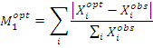 (23)
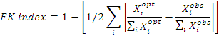 (24)

and correspond to optimal and observed crop mix respectively . and correspond to optimal and observed total land respectively. Considering total land constraint, the model does not provide the chance for total land variation . Consequently =.
The first step of validation will be applied to the 27% of farms with two different sets of weights in order to select the suitable type of function. The base year of our analysis is considered the most recent year (2012).
Table 4 FK-Index results of farms with two set of criteria weights.
farm | FK INDEX_gross margin criterion | FK INDEX_multiciteria | FK_INDEX_family labor criterion
f2 | 0.974 | 0.974
f4 |  | 0.714 | 0.676
f6 | 0.755 | 0.755
f8 | 0.787 | 0.787
f19 | 0.892 | 0.892
f22 | 0.783 | 0.783
f25 | 0.653 | 0.653
f28 | 0.155 | 0.155
f33 | 0.877 | 0.877
f40 | 0.968 | 0.968
f43 | 0.805 | 0.805
f45 | 0.383 | 0.383
f48 | 0.833 | 0.833
According to table 4, the specific group of farms express the same efficiency between single criterion function and utility function, except of one farm that utility function gives better efficiency. The similarity of results is due to the fact that distribution of weights among criteria is marginal(see also appendix).For 69% of farms, the decision making concerning crop mix , is represented by single criterion linear programming model and for the rest by multi-criteria linear programming model. Consequently , we optimize a hybrid linear programming model. As can be seen in Figure 1 ,for almost 10% of sample farms FK-index ranges from 15% to 69%, for almost 50% from 70% to 99% and for almost 40% the highest level of efficiency which corresponds to 100% is observed.
Figure 1 Predictive capacity in terms of farm
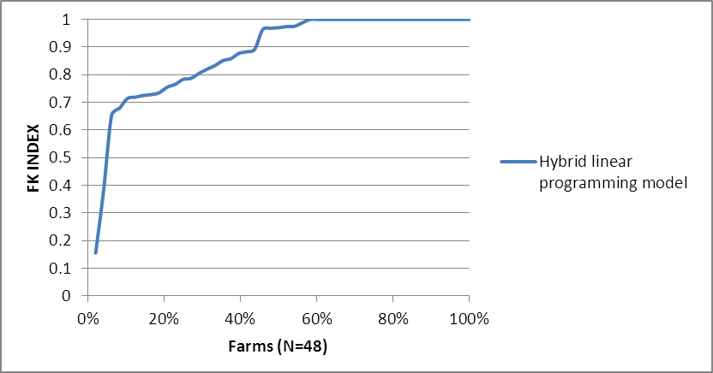
The relative distance per crop ranges from 0-3% and the overall relative distance equals to 12%. Cotton and durum wheat which are the most significant cultivations in terms of land coverage are characterized by a very low relative distance, namely 1% . Concerning Finger-Kreinin index, equals to 94%.
Table 5 Predictive capacity per crop
Crop | Observed 2012 | Hybrid linear programming model | Relative distance per crop
Cotton | 467,9 | 475,3 | 1%
Tobacco | 58,6 | 46,1 | 1%
Maize | 27 | 0 | 3%
processed tomato | 31 | 31 | 0%
processed pepper | 30 | 33,5 | 0%
Alfalfa | 66,5 | 85,7 | 2%
d. wheat | 139 | 129,3 | 1%
set aside | 27,2 | 46,6 | 2%

The Hybrid linear programming model ,can be useful for policy analysis considering that mathematical programming models with similar predictive capacity have been used for policy analysis.(Rozakis,2011; Kazakci et al.,2009;Petsakos & Rozakis,2009)
Figure 2 Illustration of the relation between reality and hybrid model results 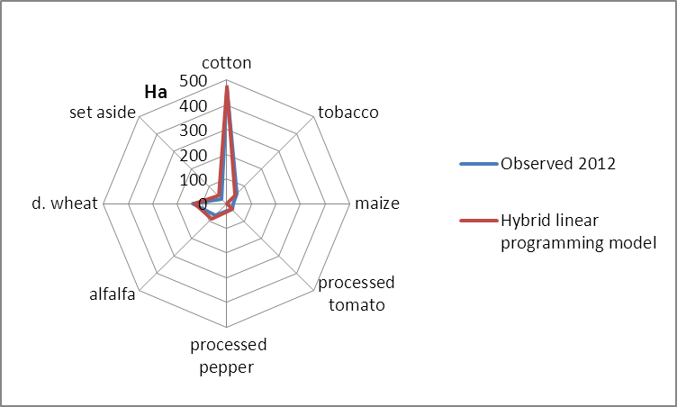

3.3 New CAP(2014-20) and model specification
At this section the adjustments in Hybrid linear programming model 2012, concerning CAP 2014-20 are described, in order to estimate the impacts of the reform, at last year of subsidies convergence (2019). As we mentioned in the previous section, Greek government opted for the partial convergence scheme for direct payments in the context of new CAP 2014-20. The period of convergence started at 2015 and will be completed at 2019. In order to implement the partial convergence scheme, Greek agriculture is separated in three different agronomic regions, namely arable farming region , tree cultivating region and pasture region . Focusing on arable farming region, the average entitlement value per hectare for the period 2015-19 equals 420 euro/ha. This value is compared to the initial value of decoupled payment per hectare of each farm for the purpose of the calculation of new CAP decoupled payment. The initial value of decoupled payment as detailed in formulation:
(25)
The decoupled payment value of 2014 was decreased by 15%, because of the economic resources transportation to Second Pillar of CAP. Additionally, each hectare of farm for the year 2015 , corresponds to a new CAP land entitlement(Hellenic Ministry of Agriculture,2014).
In case that a farm has an Initial value of decoupled payment lower than 90% of average region entitlement value per hectare (420 euros/ha), then the Initial value of decoupled payment will be increased by 33% of the difference between Initial value of decoupled payment and 90% of average entitlement value of the region until 2019. In case that a farm has Initial value of decoupled payment larger than average region entitlement value per hectare, then the Initial value of decoupled payment will be decreased by 30% until 2019. In case that a farm has Initial value of decoupled payment lower than average region entitlement value per hectare, then the Ιnitial value of decoupled payment will be achieve at least the 60% of average region entitlement value per hectare until 2019. In any of these conditions , the convergence process is linear , thus, farms loose or gain fixed amount each year(Hellenic Ministry of Agriculture,2014).
In our analysis, the most recent data concerning decoupled payment correspond to year 2012 . Consequently, we apply the formulation above for year 2012. Additionally , as new CAP entitlements for each farm are considered the total land hectares of year 2012 .
After calculating new CAP decoupled payment per hectare for each farm that will be stands at 2019, we adjusted accordingly the parameters of decoupled payment per hectare and land entitlements of Hybrid linear programming model 2012 . Also, we added three constraints to represent the obligations of farms, in order to be received whole new CAP decoupled payment (Greek Ministry of Agriculture,2014) (see also appendix for more information). Policy constraints-First pillar
1. Entitlements activation:

(26)
Set aside area cannot exceed 50% of the land entitlements area.
2. Crop diversification obligation for farms with land entitlements area > 10 hectares:
, n=1,2,3….N (27)
Cropping area of each crop cannot exceed 75% of the land entitlements area.

3. Ecologic focus area obligation for farms with land entitlements area > 15 hectares:
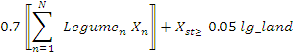 (28)
The 70% of sum of legume crops area plus set aside area must be at least equal to 5% of land entitlements area.
At this point, we would like to refer that farms with land entitlements area larger than 15 hectares are also obligated to apply the constraint 2.
Except of the decoupled payment adjustment and the inclusion of new policy constraints, we also modified the availability of resources, namely the working capital. According to 2012 data, 63% of farms intent the decoupled payment for covering working capital requirements. Thus, we tried to predict the working capital levels at last year of convergence (2019), according to formulations below. For farms with working capital larger than decoupled payment stands the formulation 1, and the formulation 2 stands for farms with the opposite relation. Consequently , we adjusted accordingly the parameter that concerns working capital . For the rest of farms (37%) , working capital was assumed invariable at 2012 levels.

- Projected working capital_2019= working capital (2012) +added value (or removal) of projected decoupled subsidy_2019 (29)
2. (30)
Another significant modification of the model concerns the land subsidies that stand for year 2019 . More specifically , for cotton equals 750 euros/ha, for durum wheat equals 55 euros/ha to ,for alfalfa equals 167 and for processed tomato equals 402 euros/ha. The rest of parameters and constraints that stand for Hybrid linear programming model 2012, were assumed invariable at 2012 levels.

3.4 Third Memorandum taxation measures and model specification
In August 2015, Third Memorandum was enshrined in Greek Law. The new taxation measures contain the agricultural sector and may affect the viability of Greek farms. The measures that will be applied concern the agricultural inputs and the profit tax. More specifically, at the ends of 2016 will be abolished the tax allowance of diesel oil(Agronews,2015) . Concerning profit tax , rate will be increased from 13% at 2015 to 26% at 2017 and the rate of prepaid profit tax will be increased from 75% at 2015 to 100% at 2016.(Niforopoulos & Papadimitriou,2016). In order to estimate the impacts of new taxation measures in combination with new CAP , we calculated the new diesel oil cost which is increased by 38,7% , then we adjusted the parameter of crop variable cost of new CAP model . Additionally, we adjusted the new profit tax in projected gross margin of 2019 , compared to gross margin of Hybrid linear programming model 2012 in which has been applied tax coefficient equals to 13%. Accordingly , we examined one more scenario, that combine these two important institutional interventions(CAP reform, Third Memorandum).
4.Results
The Hybrid linear programming model 2012 will be used to evaluate the impacts of new CAP and Third Memorandum taxation measures , focusing at last year of decoupled payments convergence, namely at 2019. The model has been modified accordingly for each of two scenarios, namely New CAP 2019 scenario and New CAP and Tax Measures 2019. The scenario impact analysis corresponds to comparative static analysis, since the model does not provide the chance for total land variability. Before we analyze the impacts of scenarios in crop mix and viability of farms, we would like to present the impacts on model parameters that affected by each scenario.
Concerning , decoupled payments , 100% of sample farms will lose 303,87 thousand euros of decoupled payment. In average terms, decoupled payment per entitlement will be decreased from 1780 euros to 710 euros. Apparently , this evolution could be affect farmers decision making since 63% of farms intend the decoupled payment for covering working capital needs. It was projected that for 63% of farms, will be lost 163 thousand euros of working capital . For the rest of the farms , working capital remain invariable since they use decoupled payment to cover alternative costs(e.g. family expenses, investment loans , home loans)
Figure 3 Partial convergence impacts to decoupled payments and working capital
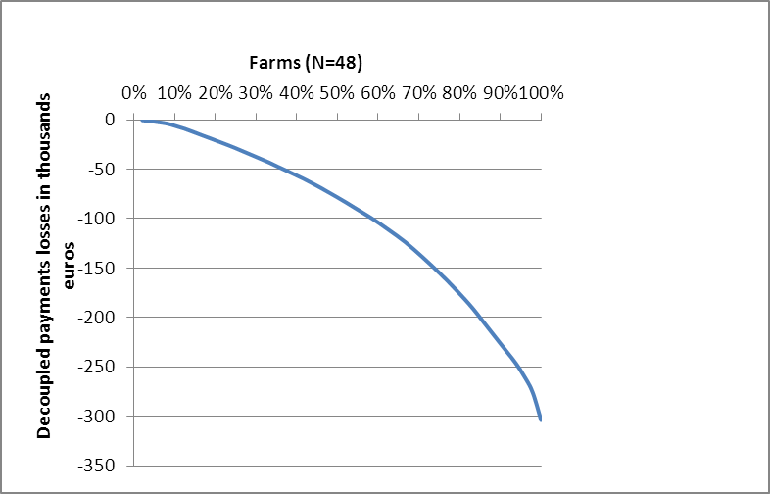
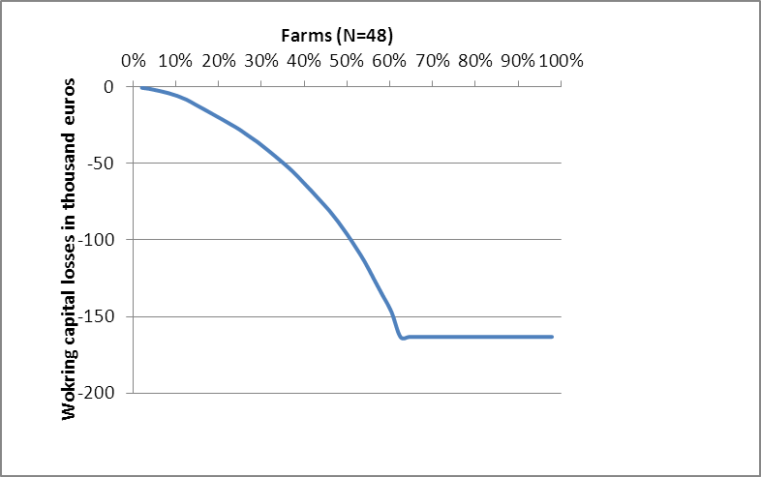

Regarding the diesel oil cost, we applied the abolishment of tax allowance at 2012 farm data and we estimated an increase of diesel cost by 38,7%. Consequently , we predicted and adjusted the variable cost of each candidate crop for each farm . In the process of predicting the cost, we also took into consideration the level of owned machinery of each farm ,assuming that the increase of diesel cost will also affect the rental rates of machinery. Thus, we adjusted the rental rate of machinery accordingly. In case of cotton , variable cost is increased by an average of 5% for the farmers who own the harvesting machinery and 10% for the rest. In case of tobacco , variable cost is increased by an average of 5% for owners of biomass boilers of drying kilns and by 16% for owners of diesel oil boilers . In case of alfalfa , variable cost increased by an average of 4% for the owners of harvesting machinery and 19% for the rest. In case of processed tomato, variable cost is increased by an average of 3% for the owners of the harvesting machinery and 10% for the rest. In case of crops that is not owned harvesting machine by any farm, namely the durum wheat , maize and processed pepper variable cost is increased by an average of 13%, 7% and 2% respectively .
Figure 4 Optimization results per crop and scenario
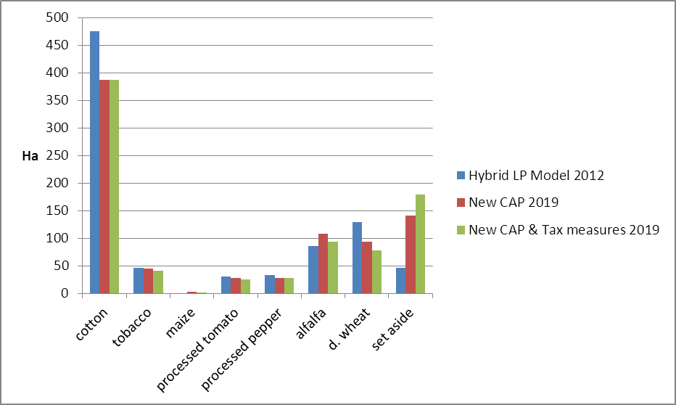

After optimizing the two variants of hybrid linear programming model 2012 , is revealed the overall crop mix for each scenario . As can be seen, for new CAP 2019 scenario is observed significant decrease for the cotton and significant increase for the set aside . Cotton is decreased , maybe due to 1) farmers with land entitlements larger than 10 ha are obligated to diversify their land according to new CAP greening constraint 2) the alfalfa becomes more competitive due to the implementation of land subsidy and at the same time cotton is characterized by a reduced land subsidy 3) farmers with decreased working capital abandon their cotton cultivation and replaced it with set aside .Set aside is increased , maybe due to 1) farmers with land entitlements larger than 15 hectares are obligated to keep an ecologic focus area in their farm either cultivating legumes or keeping land on set aside 2) farmers with decreased working capital abandon cotton or/and durum wheat and replaced them with set aside and at the same time they activate their land entitlements in line with the requirement that set aside does not exceed the 50% of land entitlements.
As regard the New CAP and Tax measures 2019 scenario, generally are not observed significant variations compared to New CAP 2019 . As important variation ,could be characterized the additional increase of set aside , maybe ,because of considerable increase of cost for durum wheat and alfalfa . Both scenarios reveal a major decrease of irrigated land. This variation could be characterized positive under circumstances ,taking into consideration that water resources of Greek arable farming are considered quite lumbered.
Table 6 Optimization results per crop and scenario (in Ha)
Scenario | Hybrid LP Model 2012(Baseline) | New CAP 2019 | New CAP & Tax measures 2019
cotton | 475,31 | 386,62 | 387,58
tobacco | 46,10 | 44,78 | 41,28
maize | 0 | 3,12 | 1,36
processed tomato | 30,97 | 27,79 | 25,12
processed pepper | 33,50 | 27,78 | 27,50
alfalfa | 85,70 | 108,17 | 93,73
d. wheat | 129,29 | 93,94 | 77,96
set aside | 46,60 | 140,86 | 178,53

According to ESU index , is observed increase of small farms for both scenarios. More specifically , small farms category becomes the major category for both scenarios and at the same time , the largest decrease is observed for the large farms. Apparently these deviations are due to the fact that is decreased the decoupled payment and are increased the cost of diesel oil and the profit tax rate.
Table 7 Allocation of farms according to ESU for each scenario
Economic Size Unit (ESU)
ESU<16  (Small farms) | 16≤ESU≤40  (Medium farms) | ESU >40  (Large farms)
Hybrid LP 2012 35.41% | 41.66% | 22.91%
New CAP 50%  2019 | 37,5% | 12,5%
New CAP& 56,25%  Tax Measures | 33,33% | 10,41%

Except of the use of ESU categories in order to assess the economic impacts of scenarios , it would be useful to assess the viability of farms. As viability index of farms we use the return to working capital , that had been used in order to estimate the impacts of CAP reform 2003 to Greek cotton farmers( Rozakis et al., 2008). The formulation of index as follows:
Return to working capital =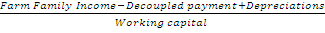 (31)
In case that for two consecutive years , return to working capital is lower than interest rates from simple bank deposits , rational farmers would not keep on cultivating, given that they receive a significant amount in the form of decoupling payment.
Taking into consideration that in our analysis we use the economic index of gross margin , we adjust the return to working capital formulation accordingly as follows:
Return to working capital =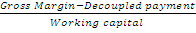 (32)
The current interest rate of deposit of Greek banks corresponds almost to 2% . Then we compare the return to working capital (for each farm and scenario ) with interest of 2%.
Figure 5 Viability of farms for each scenario 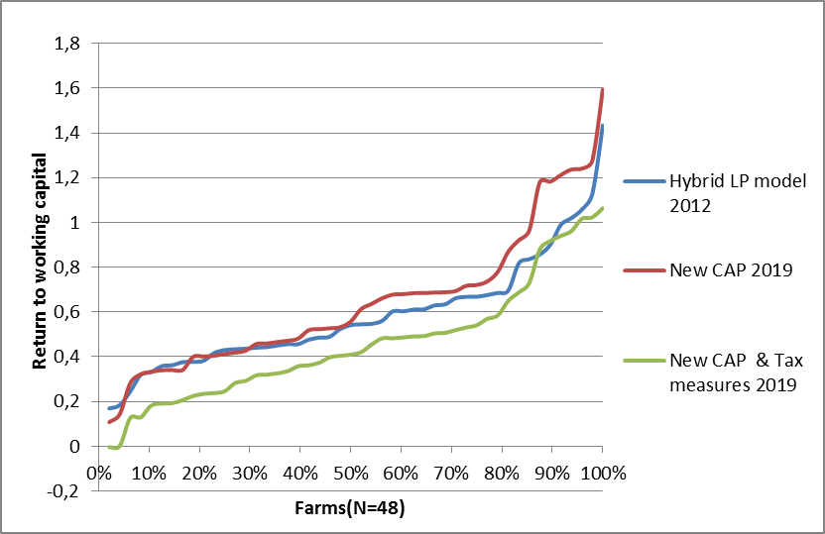

According to figure 5 , sample farms considered more viable in the context of New CAP 2019 scenario . Although the reduction of decoupled payment for all sample farms , the difference between gross margin and decoupled payment remains almost invariable and at the same time is observed a decrease of working capital(see also table 8) . This result reveals that farmers become more efficient in the context of New CAP scenario ,increasing the percentage of gross revenue that received mainly from the market and secondary from the low amount land subsidies.
In case of New CAP & Tax measures 2019 scenario ,the sample farms are less viable compared to baseline and New CAP 2019 scenario, because of the increase of tax profit rate from 13% to 26% and the increase of diesel oil cost by 38,7% in the context of abolishment of tax allowance. Additionally, it is observed a 4% of non-viable farms for the specific scenario. In general, sample farms could be characterized as viable due to they receive 64% of their gross revenue from the market. Consequently, they are not affected enough by CAP reforms that may reduce their subsidies levels. The combination of CAP reform and taxation measures of Third Memorandum could reduce their viability significantly ,but even if that scenario 96% of farms remain viable.
Table 8 Economic results and parameters in the sample farms for each scenario
 | Gross Margin(million euros) | Decoupled Subsidy(million euros) | Working Capital(million euros)
Hybrid LP model 2012 | 1,64 | 0,78 | 1,34
New CAP 2019 | 1,3 | 0,48 | 1,18
New CAP & Tax measures 2019 | 1,08 | 0,48 | 1,18

5. Conclusions
The aim of this study was to estimate the impacts of CAP and taxation reforms in crop mix and viability of Greek business oriented farms. For the purposes of analysis , was used multicriteria mathematical programming model in order to estimate the utility functions that represent the crop mix decision making of a sample farms located in regional unit of Karditsa . The validation results of model confirm that most of business oriented farms are willing to optimize their economic results ,namely the gross margin . Although, the business oriented type of farms , model results reveals that almost 20% of farms still contain the element of family labor in the process of crop mix decision making . Generally , the sample farms are almost concentrated in one goal when plan the crop mix of the following year . Regarding the impacts of CAP reform in crop mix , is observed reduction for cotton and durum wheat ,and on the other hand set aside and alfalfa are increased . From the environmental point of view , we could say that CAP reform could reduce the degradation of water resources that is observed in Greek regions of intensive agriculture like Thessaly,Central Greece and Central Macedonia . Concerning the viability of farms, are not affected negatively . In case of combined scenario (CAP & tax reform) , crop mix remains almost the same but the viability is decreased significantly . Even if that scenario , 96% of farms remain viable since 64% of gross revenue is derived from market.
Concerning analytical tools, further research could be undertaken , in order to estimate the impacts of policy via a sequential mathematical programming model which takes into consideration the changes of farms behavior in the mid-term period, providing more realistic results

References
Agrenda,2013.Common Agricultural Policy 2015(in Greek)Agrenda newspapers. Available at:http://www.agronews.gr/?pid=143&pdfID=1600&la=0
Agronews,2015.Tripling of diesel oil tax rate and reduction of tax return by 50% for 2016(in Greek). Available at: http://www.agronews.gr/?pid=190&aid=133555&la=1
Amador F., Sumpsi J.M. and Romero C., 1998. A non-interactive methodology to assess farmers΄ utility functions: An application to large farms in Andalusia, Spain. European Review of Agricultural Economics, 25: 92-109.
Solazzo R., Donati M., Arfini F. and Petriccione G.,2014. A PMP model for the impact assessment of the Common Agricultural Policy reform 2014-2020 on the Italian tomato sector. New Medit, 13(2): 9-19. Available at : http://www.iamb.it/share/img_new_medit_articoli/976_9solazzo.pdf
Cimino O., Henke R. and Vanni F.,2015. The effects of CAP greening on specialised arable farms in Italy.New Medit, 14(2):22-31.
Donati M., Menozzi D. and Fioravzanzi M.,2015. Understanding farmers’ responses to CAP reform. New Medit, 14(3):23-39. Available at : http://www.iamb.it/share/img_new_medit_articoli/1027_29donati.pdf
European Commission, 2015. Member States Factsheets – Greece. Available at: http://ec.europa.eu/agriculture/statistics/factsheets/pdf/el_en.pdf
European Commission, 2012b. Generational renewal in EU agriculture: Statistical background.EU Agricultural Economic Briefs, Brief N° 6 – June 2012 . Available at: http://ec.europa.eu/agriculture/rural-area-economics/briefs/pdf/06_en.pdf
Finger J.M. and Kreinin M.E. (1979). A measure of ‘Export similarity’ and its possible uses. Economic Journal ,89: 905-912.
Hellenic Ministry of Agriculture, 2014. The context of Common Agricultural Policy after 2015-First Pillar: Direct Payments (in Greek). Available at: http://www.minagric.gr/images/stories/agropol/Greek/Agro_pol/KAP/Parousiasi_gia_site_short_FINAL.pdf
Karanikolas P., Rozakis S. and Kremmydas,D., 2013. The multiplicity of goals in tree-cultivating farms in Greece. Working Papers 2013-2, Agricultural University of Athens, Department Of Agricultural Economics. Available at: http://aoatools.aua.gr/RePEc/aua/wpaper/files/2013-2_karanikolas_multiplicity.pdf
Kazakci A., Rozakis S. and Sourie J-C.,2009. Min-max regret versus gross margin maximization in arable sector modeling. Agricultural University of Athens, Department Of Agricultural Economics .Working Papers , 1-33. Available at: http://aoatools.aua.gr/RePEc/aua/wpaper/files/2009-1_ILPpaper_090224.pdf
Manos B., Bournaris T., Papathanasiou J. and Chatzinikolaou P., (2009) Evaluation of tobacco cultivation alternatives under the EU CAP. Journal of Policy Modeling, 31:225–238.
Mantziaris, S., 2013. Verification of the predictive capacity of arable farm-based mathematical programming model in regional unit of Karditsa for the period 2005-12. MSc Thesis, Agricultural University of Athens, Dept. of Agricultural Economics and Rural Development, Greece (in Greek)
Mattas K., Loizou E., Rozakis S., Tzouvelekas E.,2006. Agricultural modelling: an input-output approach,. F. Ferretti (ed.), Leaves and Cigarettes : Modelling the tobacco industry, with application to Italy and Greece, Milano: Francoangeli Publisher.
.Niforopoulos K. and Papadimitriou G.,2016. Taxation of agricultural sector.Issues and concerns (in Greek). Available at:
http://www.agrotechniki.gr/NewsFiles/1_%CE%A6%CE%9F%CE%A1%CE%9F%CE%9B%CE%9F%CE%93%CE%99%CE%91%20%CE%91%CE%93%CE%A1%CE%9F%CE%A4%CE%A9%CE%9D_%CE%98%CE%95%CE%A3_29-1-16_%CE%A4%CE%95%CE%9B.pdf
Petsakos A. and Rozakis S., 2009. Critical Review and State-of-the-Art of PMP Models: An Application to Greek Arable Agriculture, Research Topics in Agricultural and Applied Economics, Bentham Science Publishers 1:36-63.
Petsakos A. and Rozakis S.,2015. Calibration of agricultural risk programming models.European Journal of Operational Research ,242: 536-545.
Petsakos A., Rozakis S. and Tsiboukas K., 2009. Risk optimal farm plans in the context of decoupled subsidy payments: the case of cotton production in Thessaly, Journal of Farm Management ,13(7): 467-483.
Region of Thessaly, 2011. Operational plan: Agricultural products of Thessaly (in Greek). Available at: http://www.pthes.gov.gr/data/anakoin/2012/an138a.pdf
Rozakis S., Tsiboukas K. and Korasidis M.,2008. CAP Reform Impacts To Greek Cotton Farmers: A Mathematical Programming Approach. Journal of Agricultural and Food Economics, 3(1-2): 95-116 .
Rozakis S., 2011. Impacts of flatter rates and environmental top-ups in Greece: A novel mathematical modeling approach, Agricultural Economics Review ,12 (2 ): 30-39. http://www.eng.auth.gr/mattas/12_2_3.pdf
Sintori A., Rozakis S. and Tsiboukas C.,2010. Utility-derived supply function of sheep milk: The case of Etoloakarnania, Greece, Food Economics - ActaAgricultura Scandinavia C, 7 (2-4): 87-99.
Sourie J-C. and Rozakis S., 2001. Bio-fuel production system in France: An Economic Analysis. Biomass and Bio-energy, 20(6) :483-489.

Appendix
Appendix.1

Indices
n | Crop (cotton, tobacco, processed pepper, processed tomato, alfalfa, maize, durum wheat, set-aside)
Decision Variables
 | cropping area of each crop in hectares
 | set-aside area in hectares
Parameters
 | expected crop yield of each crop in tn/ha(Data yields of 2005 & 2006 are used in order to calculate expected crop yields)
expected price of each crop in euros/ton
Average t-1 price (2011) for non-contracted crops ( Cotton price=530 euros/ton, maize price=180 euros/ton , alfalfa price=220 euros/ton, durum wheat price =210 euros/ton.)

 | indicative coupled subsidy of each crop in euros/ha (cotton=805 euros/ha, durum wheat=90euros/ha)
 | variable cost of each crop in euros/ha
 | provided family labor for each crop in hours/ha
 | irrigated arable crop ( cotton, tobacco, processed pepper, processed tomato, alfalfa, maize)
 | eligible crop for entitlement activation(cotton, tobacco, processed pepper, processed tomato, alfalfa, maize, durum wheat, set-aside)
 | eligible crop for irrigated rotation in context of nitrogen reduction program(cotton)
 | eligible crop for non-irrigated rotation in context of nitrogen reduction program(durum wheat)
 | eligible crop for organic farming(alfalfa)
 | Legume crop (alfalfa)
lg_land | land entitlements area in hectares
pay | single payment in euros/ha
lg_organic | land entitlements of organic program in hectares
orgpay | organic payment in euros/ha
lg_nitro_A | land entitlements of nitrogen pollution reduction program in hectares- methodology A
nitropay_A | nitrogen pollution reduction program methodology A payment in euros/ha
lg_nitro_B | land entitlements of nitrogen pollution reduction program in hectares- methodology B
nitropay_B | nitrogen pollution reduction program payment in euros/ha -methodology B
 | Available arable land
 | Available irrigated land
 | Available working capital
 | Available family labor
Appendix.2
Criteria weights per farm ( 1=gross margin maximization,2=family labor maximization,3=working capital minimization), missing farms pursue optimization of gross margin
 | set of criteria 1 |  |  | set of criteria 2
farm id | 1 | 2 | 3 | 1 | 2 | 3
farm 1 | 100,0%
farm 2 | 99,9% |  | 0,1% | 100,0%
farm 4 | 95,6% | 4,4%
farm 6 | 90,2% | 9,8% |  | 100,0%
farm 7 | 100%
farm 8 | 99,8% | 0,02 % |  | 100,0%
farm 14 |  | 100,0%
farm 17 |  | 100,0%
farm 19 | 97,1% | 2,9% |  | 100,0%
farm 22 | 99,6% | 0,04% |  | 100,0%
farm 23 |  | 100,0%
farm 24 | 99,8% | 0,02%
farm 25 | 99,2% | 0,08% |  | 100,0%
farm 28 | 90,3% | 9,7% |  | 100,0%
farm 29 | 84,7% | 15,3%
farm 30 |  | 100,0%
farm 34 |  | 100,0%
farm 35 |  | 100,0%
farm 40 | 98,2% | 1,8% |  | 100,0%
farm 43 | 95,8% | 4,2% |  | 100,0%
farm 44 |  | 100,0%
farm 45 | 100,0% |  |  | 86,4% | 13,6%
farm 46 |  | 100,0%
farm 48 | 94% | 6% |  | 100%

Concerning the 22 farms that we did not updated their data ,45% retire,23% abandoned farming and for the rest ,unfortunately we do not have any specific information .
Mathematical programming models of current paper are written in GAMS code and solved by CPLEX algorithm.
When the observed and optimal crop mix are identical the FK index becomes 100%.
We take into consideration the non-taxable limit that stands for subsidies up to 12.000 euros. The estimation does not include depreciations and prepaid tax .
Agri-environmental subsidies are considered invariable .
In parentheses are described the possible choices of sample farms.

