AUA Working Paper Series No. 2016-1
May 2016

Impact assessment of agricultural and fiscal policy in Greece on business-oriented arable farms

Stamatis Mantziaris
Postgraduate Program MBA in Agribusiness, Agricultural University of Athens
sta.athens@hotmail.com

Stelios Rozakis
Environmental Engineering Department, Technical University of Crete
srozakis@isc.tuc.gr

This series contains preliminary manuscripts which are not (yet) published in professional journals
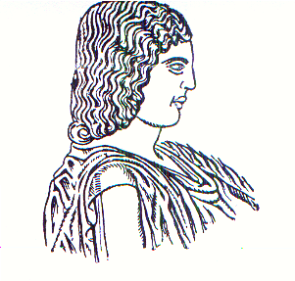
Agricultural University of Athens ∙
Department of Agricultural Economics
& Rural Development ∙ http://www.aoa.aua.gr

