AUA Working Paper Series No. 2015-3
October 2015

Dealing with farm heterogeneity on modeling agricultural policy:
An Agent Based Modeling Approach

Dimitris Kremmydas†
Department of Agricultural Economics and Rural Development, Agricultural University of Athens
kremmydas@aua.gr

Stelios Rozakis
Department of Agricultural Economics and Rural Development, Agricultural University of Athens
rozakis@aua.gr

Ioannis Athanasiadis
Electrical and Computer Engineering Dept. of Democritus University of Thrace, in Xanthi, Greece
ioannis@athanasiadis.info

† Corresponding Author

A preliminary version of this paper was presented in the 20th Annual Workshop on the Economic Science with Heterogeneous Interacting Agents (WEHIA), in Sophia Antipolis, in the Côte d'Azur region of France, on May 2015
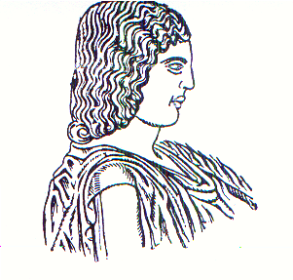
Agricultural University of Athens ∙
Department of Agricultural Economics
& Rural Development ∙ http://www.aoa.aua.gr

