AUA Working Paper Series No. 2015-2
September 2015

Should I double park or should I go? The effect of political ideology on collective action problems

Antonis Adam†
Assistant professor, Department of Economics, University of Ioannina, University campus, 45110, Greece,
aadam@cc.uoi.gr

Andreas C. Drichoutis
Department of Agricultural Economics and Rural Development, Agricultural University of Athens
adrihout@aua.gr

Maria Georgoula
Department of Economics, University of Ioannina, University campus, 45110, Greece,
georgoulam@yahoo.gr

Pantelis Kammas
Assistant professor, Department of Economics, University of Ioannina, University campus, 45110, Greece,
kammas@cc.uoi.gr

† Corresponding Author

This series contains preliminary manuscripts which are not (yet) published in professional journals
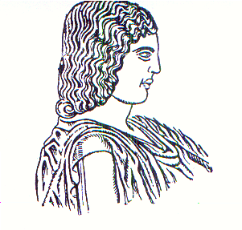
Agricultural University of Athens ∙
Department of Agricultural Economics
& Rural Development ∙ http://www.aoa.aua.gr

