AUA Working Paper Series No. 2015-1
January 2015

Farm Production Costs, Producer Prices and Retail Food Prices:
A Cointegration Analysis

Christos P. Pappas
Department of Agricultural Economics and Rural Development, Agricultural University of Athens
christ.pappas@gmail.com

Christos T. Papadas†
Department of Agricultural Economics and Rural Development, Agricultural University of Athens
cpap@aua.gr

† Corresponding Author

This series contains preliminary manuscripts which are not (yet) published in professional journals
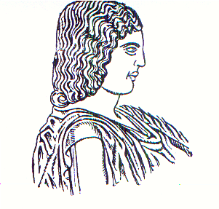
Agricultural University of Athens ∙
Department of Agricultural Economics
& Rural Development ∙ http://www.aoa.aua.gr

