AUA Working Paper Series No. 2014-7
December 2014

Allocating shadow prices
in a multiobjective
chance constrained model
for biodiesel blending

C. Caldeira†, F. Freire
Department of Mechanical Engineering, Faculty of Sciences and Technology, University of Coimbra, Portugal
carla.caldeira@dem.uc.pt

L. Dias
Faculty of Economics, University of Coimbra, Portugal

D. Kremmydas, S. Rozakis
Department of Agricultural Economics and Rural Development, Agricultural University of
Athens

† Corresponding author

This series contains preliminary manuscripts which are not (yet) published in professional journals
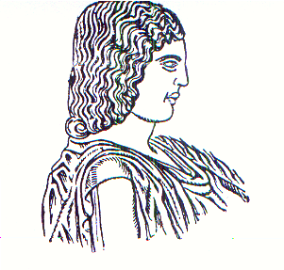
Agricultural University of Athens ∙
Department of Agricultural Economics
& Rural Development ∙ http://www.aoa.aua.gr

