AUA Working Paper Series No. 2014-2
30 April 2014

Food environment and childhood obesity: The effect of dollar stores

Andreas C. Drichoutis
Department of Agricultural Economics, Agricultural University of Athens
adrihout@aua.gr

Rodolfo M. Nayga
Department of Agricultural Economics & Agribusiness, Division of Agriculture, University of Arkansas
rnayga@uark.edu

Heather L. Rouse
College of Medicine, Department of Pediatrics, University of Arkansas for Medical Sciences
HLRouse@uams.edu

Michael R. Thomsen
Department of Agricultural Economics & Agribusiness, Division of Agriculture, University of Arkansas
mthomsen@uark.edu

This series contains preliminary manuscripts which are not (yet) published in professional journals
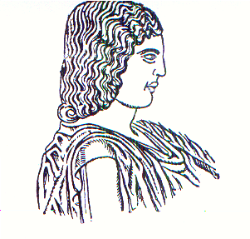
Agricultural University of Athens ∙
Department of Agricultural Economics
& Rural Development ∙ http://www.aoa.aua.gr

