AUA Working Paper Series No. 2013-6
December 2013

Multi-Criteria Decision Making on the Energy Supply Configuration of Autonomous Desalination Units

Dimitris Georgiou
Postgraduate program in Agribusiness Management
Agricultural University of Athens

Essam Sh. Mohammed
Department of Natural Resources Management and Agricultural Engineering, Agricultural University of Athens

Stelios Rozakis
Department of Agricultural Economics and Rural Development
Agricultural University of Athens
s.rozakis@aua.gr

This series contains preliminary manuscripts which are not (yet) published in professional journals
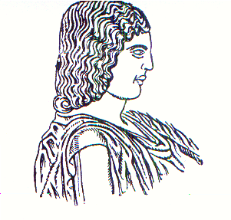
Agricultural University of Athens ∙
Department of Agricultural Economics
& Rural Development ∙ http://www.aoa.aua.gr

