AUA Working Paper Series No. 2013-5
December 2013

Nudging parental health behavior with and without children's pestering power: Fat tax, subsidy or both?

Georgia S. Papoutsi (Corresponding Author)
Agricultural University of Athens, Iera Odos 75, Athens, 11855, Greece, gpapoutsi@aua.gr

Rodolfo M. Nayga, Jr
University of Arkansas, Fayetteville, AR 72701, USA & Norwegian Agricultural Economics Research Institute & Korea University

Panagiotis Lazaridis
Agricultural University of Athens, Iera Odos 75, Athens, 11855, Greece

Andreas C. Drichoutis
Agricultural University of Athens, Iera Odos 75, Athens, 11855, Greece

This series contains preliminary manuscripts which are not (yet) published in professional journals
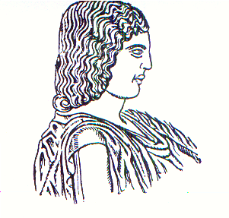
Agricultural University of Athens ∙
Department of Agricultural Economics
& Rural Development ∙ http://www.aoa.aua.gr

