AUA Working Paper Series No. 2013-1
January 2013

Irrigation Full Cost Assessment: The case of the Pinios Local Organization for Land Reclamation, Greece

Kampas A†., Vasilaki A., Petsakos A.
Department of Agricultural Economics and Rural Development, Agricultural University of Athens, Iera odos 75, 18855, Athens

Stefopoulou A.
Department of Natural Resources Development and Agricultural Engineering, Agricultural University of Athens, Iera odos 75, 18855, Athens.

†Corresponding author, tkampas@aua.gr

This series contains preliminary manuscripts which are note (yet) published in professional journals
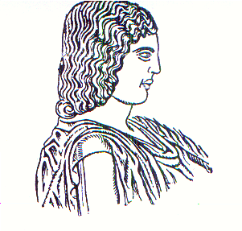
Agricultural University of Athens ∙
Department of Agricultural Economics
& Rural Development ∙ http://www.aoa.aua.gr

