AUA Working Paper Series No. 2012-5
December 2012

The Politics of CAP: The case of Greece

Stathis Klonaris
s.klonaris@aua.gr

George Vlahos
gvlahos@aua.gr

Dept. of Agricultural Economics and Rural Development, Agricultural University of Athens

This series contains preliminary manuscripts which are note (yet) published in professional journals
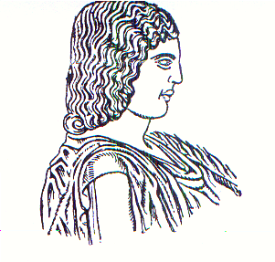
Agricultural University of Athens ∙
Department of Agricultural Economics
& Rural Development ∙ http://www.aoa.aua.gr

