AUA Working Paper Series No. 2012-2
December 2012

Economic and spatial modelling for estimating supply of perennial crops’ biomass in Poland

P. Mathiou, S. Rozakis†
Department of Agricultural Economics and Development
Agricultural University of Athens, Greece

R. Pudelko, A. Faber
Dept. of Agrometeorology and Applied Informatics
Institute of Soil Science and Plant Cultivation, Poland

†Corresponding author, rozakis@aua.gr

This series contains preliminary manuscripts which are note (yet) published in professional journals
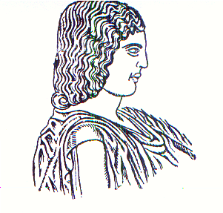
Agricultural University of Athens ∙
Department of Agricultural Economics
& Rural Development ∙ http://www.aoa.aua.gr

