AUA Working Paper Series No. 2010-6
October 2010

Stochastic Convergence and Distribution Dynamics of Food Price Inflation Rates in EU

Angelos Liontakis
Department of Agricultural Economics & Rural Development
Agricultural University of Athens
aliontakis@aua.gr

Christos T. Papadas
Department of Agricultural Economics & Rural Development
Agricultural University of Athens
cpap@aua.gr


Agricultural University of Athens ∙
Department of Agricultural Economics
& Rural Development ∙ http://www.aoa.aua.gr

Abstract. Concepts and developments in the literature of economic growth and convergence have recently been adopted and used in the study of inflation rate convergence. This paper examines initially the existence of β-convergence, as mean reversion, of food price inflation rates in the European Union, using the stochastic convergence approach of panel data unit root tests. It examines also the existence of σ-convergence but in order capture sufficiently the evolving distributional dynamics, non-parametric econometric methods are implemented as well. An alternative conditional density estimator, proposed in the literature, is applied for this reason. This estimator is chosen as superior, not only to the restrictive discrete Markov chain approaches but also to the usual estimators of conditional densities using stochastic kernels. Monthly data on the EU harmonized consumer price indices of food and eleven specific food product subgroups are used, for the 15 older EU member states, covering the 1997-2009 period.
Keywords: Kernel density estimator, convergence, distribution dynamics, food price inflation.

1. Introduction
The subject of inflation rate convergence gained attention due to its importance for monetary and regional policies, monetary unions, and the regional distribution of trade and growth effects. Empirical studies on this subject followed the introduction and development of quantitative methods in the area of economic growth and convergence.
Many studies focused on inflation rate convergence between regions of the same country. Cecchetti et al. (2002) and Roberts (2006) examined inflation convergence trends within US. Dayanandan and Ralhan (2005) investigated price index convergence among Canadian districts and cities. Fan and Wei (2006) investigated inflation convergence among 36 Chinese cities, Busetti et al. (2006) tested for convergence among Italian regions and Yilmazkuday (2009) tested for inflation rate convergence among different Turkish regions.
Other studies referred to a group of countries such as the members of the European Monetary Union (EMU) or the new members of the European Union. Such studies are found in the works of Rogers (2001), Montuega-Gomez (2002), Sarno and Zazzaro (2003), Altissimo et al. (2005), Kutan and Yigit (2005), Weber and Beck (2005), Busetti et al. (2007), Boschi and Giraldi (2007), Lopez and Papell (2010), Sturm et al. (2009), Erber and Hagemann (2009), Coricelli and Horvath (2010). Moreover, EU inflation rate convergence has been analyzed relative to a benchmark, most commonly the corresponding indices of US or Japan (e.g. Beck et al., 2006). Some other studies dealt with the issue of global inflation rate convergence and dispersion of the relevant distribution (e.g. Lee and Wu, 2001 and Borio, 2007).
It is widely recognized that inflation as a monetary phenomenon, is determined in the long-run by money supply. In the short-run however, other forces may play a role too, especially for small range changes. Such forces can also be used to explain longer term inflation rate differentials at the regional level or different regional responses to similar monetary policies. In the literature, inflation rate differentials have been associated with the productivity catching-up process (eg. Canzoneri, 2003), and with monetary and fiscal factors (e.g. Cecchetti et al., 2002 and Weber and Beck, 2005). Dalsgaard (2008) emphasised the role of market concentration, mergers and acquisitions and cartel formations. Fousekis (2008) points at the fragmentation of the European market and claims that inflation rate differentials are not efficiently confronted by horizontal EU measures but by changes in the market structures in EU countries. Most of the relevant literature focuses on convergence of price inflation rates for largely aggregated sets of commodities.
The purpose of this study is to examine convergence and the distribution dynamics of food price inflation rates for the fifteen older EU countries. Both, stochastic convergence (in particular the mean reversion case of β-convergence) and σ-convergence are considered while non parametric econometric methods are implemented to study the evolving distribution dynamics of food price inflation rates.
Data used are monthly estimates of the Harmonized Indices of Consumer Prices (HICP) for the whole group of “Food and non-alcoholic beverages”, and for eleven specific individual subgroups of food products. The data set cover a period from January 1997 to May 2009.
Dynamic panel data analysis and panel unit root tests according to Levin, Lin and Chu (2002) are used to examine stochastic convergence. Changes in standard deviation are used to examine σ-convergence, according to its concept (Sala-i-Martin, 1996). Examination of the evolving distribution dynamics is also conducted using an alternative kernel density estimator proposed by Hyndman et al. (1996), and Hyndman and Yao (2002). This estimator was introduced in the growth and income convergence analysis by Arbia et al. (2005) and it is used here to study inflation rate distribution dynamics, because it offers certain advantages.

2. A Literature Review on Food Price Inflation Rates Convergence
There have been some studies focusing on inflation rate convergence for food products. Weber and Beck (2005) examined inflation rate convergence in two samples of European countries. Their study considers changes in HICPs for the group of all products and for twelve subgroups of products including ‘Food and non-alcoholic beverages’. For the latter, they found β-convergence but they did not provide half-lives as the solution of the nonlinear expression for β-convergence they used, produced a complex number. Additionally they found that the estimated β’s were greater in the total period rather than in the period after the introduction of the common currency, implying slower β-convergence after the formation of the EMU and the existence of non-linearities in the convergence process. They found also that there is σ-convergence during the first half of the period they examined but σ-divergence for the second half of the period.
Dayanandan and Ralhan (2009) used panel unit roots tests suggested by Levine and Lin (1992) and Im, Pesaran and Shen (1997), and they found evidence of β-convergence for the food price index in Canada with a half life equal to 7.4 years. Sturm et al. (2009) estimated coefficients of variation for the consumer price index of several commodity groups including food commodities and for different groups of European countries. They found a variety of results for different commodity and food commodity groups, with regards to β and σ-convergence. Results vary also with respect to country groups (EMU and non-EMU members) and time periods.
Faber and Stokman (2008) found evidence of convergence for the consumer price index of food and non-alcoholic beverage products in Europe, and for the period 1980-2003. In early ‘90s, there was a strong price level convergence for all ‘second level’ commodity groups including food and non-alcoholic beverages. In the study of Fan and Wei (2006), panel unit root tests were used to study also convergence of the food price inflation rates across 36 major Chinese cities and over a seven year period. They found contradictory results on β-convergence based on the panel unit root test implemented and the time lag selection model. They argued that these results are stemming from the fact that high-frequency data (monthly) were used, which capture better the time period needed for price convergence. Results of other studies using lower frequency data are suffering from ‘aggregation bias’ (for this type of bias, see Taylor, 2001).
Bukeviciute et al. (2009) emphasised differences in the operation of the food supply chain and they argued that an external shock such as a rapid rise in agricultural supply or in energy prices is differently absorbed in each country, contributing to food price inflation differentials. The fragmentation implied by different degrees of external shock absorption is a possible consequence of the different market structures and regulatory framework. In this sense food price inflation differentials are a signal that the EU food market still remains fragmented.

3. Data, Variables and Descriptive Statistics
Monthly data on HICPs for ‘Food and non-alcoholic beverages’ and for eleven different subgroups, in fifteen countries (Table 1), and for the examined period, are given by Eurostat. Inflation rates are computed as annual percentage changes of the price index as follows:
$π_{t}=\text{100}(\text{ln}P_{t}−\text{ln}P_{t−1})=\text{100}(p_{t}−p_{t−1})$ (1)
where π_{t} denotes the food price inflation rate in period t, P_{t} represents the price index at period t, and p_{t} is the natural logarithm of P_{t}. The results for the ‘Food and non-alcoholic beverages’ inflation rates are summarized in Table 1. The table provides descriptive statistics – mean (M) and standard deviation (SD) - for the considered period and for the fifteen countries examined.
On average, Greece and Spain have the greatest food price inflation rate, while Sweden and Germany have the lowest. Similar data are provided also for the separate commodity subgroups included in the ‘food and non-alcoholic beverages’ group, together with their classification codes.
A look at the disaggregated product groups provides a more complex picture. Whereas Germany has, on average, the lowest inflation rate for ‘food and non-alcoholic beverages’ this is not the case for six of the nine product groups. On the other side, Greece has the highest average inflation rate for ‘food and non-alcoholic beverages’ and for five disaggregated product groups as well. Ireland has the highest average rate for ‘Oils and Fats’ and ‘Coffee, Tea and Cocoa’ but the lowest rate for ‘Food Products n.e.c.’. Spain has the lowest average inflation rate for ‘Oils and Fats’ (negative), but the highest for three other product groups. The table provides also the average inflation rates and standard deviations during the examined period, for all fifteen countries as a whole (last column).
Table 1. Descriptive statistics for the general food inflation rates and for the eleven food product groups.
 |  | Austria | Belgium | Denmark | Finland | France | Germany | Greece | Ireland | Italy | Lux/boug | Neth/lands | Portugal | Spain | Sweden | UK | AV/AGE | STD.DEV.
1.Food and Non-alcoholic beverages | M | 2.02 | 2.38 | 2.29 | 2.17 | 2.03 | 1.27 | 3.40 | 2.59 | 2.16 | 2.63 | 1.81 | 2.19 | 3.09 | 1.75 | 2.24 | 2.23 | 0.53
1.Food and Non-alcoholic beverages | SD | 1.97 | 1.96 | 2.32 | 2.59 | 1.87 | 2.26 | 2.29 | 2.41 | 1.73 | 1.43 | 2.89 | 2.08 | 2.00 | 2.23 | 3.09 | 2.16
1.1.1.Bread and cereals | M | 2.64 | 3.24 | 3.27 | 1.95 | 1.98 | 1.65 | 4.37 | 2.96 | 2.38 | 2.95 | 1.71 | 3.51 | 3.43 | 1.87 | 2.10 | 2.60 | 0.82
1.1.1.Bread and cereals | SD | 2.44 | 2.50 | 2.91 | 2.27 | 1.51 | 2.11 | 3.05 | 3.04 | 2.48 | 1.77 | 2.14 | 2.62 | 2.31 | 2.88 | 3.43 | 2.39
1.1.2.Meat | M | 1.77 | 2.09 | 1.43 | 1.32 | 2.31 | 1.21 | 2.84 | 1.93 | 1.96 | 2.30 | 1.67 | 1.26 | 2.98 | 1.47 | 1.85 | 1.88 | 0.53
1.1.2.Meat | SD | 2.28 | 1.83 | 3.04 | 3.62 | 2.29 | 2.84 | 1.86 | 3.24 | 1.85 | 1.76 | 2.94 | 3.60 | 3.07 | 2.78 | 4.15 | 2.71
1.1.3.Fish and seafood | M | 2.54 | 3.29 | 3.28 | 3.01 | 2.25 | 2.87 | 4.35 | 3.23 | 2.90 | 2.96 | 3.44 | 3.46 | 3.46 | 3.24 | 3.72 | 3.20 | 0.48
1.1.3.Fish and seafood | SD | 3.38 | 3.57 | 3.32 | 2.66 | 1.73 | 1.74 | 3.75 | 3.56 | 1.60 | 3.28 | 3.78 | 5.31 | 2.12 | 3.22 | 4.25 | 3.06
1.1.4.Milk, cheese and eggs | M | 2.11 | 2.15 | 2.47 | 2.92 | 1.80 | 1.21 | 3.75 | 3.10 | 1.84 | 2.84 | 2.01 | 1.45 | 2.93 | 2.06 | 2.64 | 2.28 | 0.72
1.1.4.Milk, cheese and eggs | SD | 3.98 | 3.80 | 3.95 | 4.47 | 2.83 | 5.16 | 1.85 | 4.57 | 2.01 | 2.99 | 4.89 | 3.36 | 4.02 | 2.80 | 4.51 | 3.54
1.1.5.Oils and fats | M | 2.21 | 2.16 | 2.92 | 2.82 | 2.34 | 1.05 | 1.37 | 3.43 | 1.73 | 2.46 | 2.17 | 0.17 | -0.20 | 1.58 | 2.21 | 1.85 | 0.97
1.1.5.Oils and fats | SD | 3.67 | 3.75 | 4.98 | 4.03 | 2.73 | 5.85 | 8.71 | 3.96 | 3.96 | 2.81 | 4.63 | 8.13 | 16.64 | 2.88 | 5.80 | 5.43
1.1.6.Fruit | M | 3.84 | 2.88 | 1.80 | 3.55 | 2.44 | 1.35 | 4.04 | 2.21 | 2.41 | 3.53 | 2.56 | 2.67 | 4.45 | 3.22 | 2.01 | 2.82 | 0.87
1.1.6.Fruit | SD | 7.61 | 5.43 | 4.27 | 5.87 | 6.57 | 4.04 | 10.86 | 2.72 | 4.36 | 3.29 | 4.81 | 5.81 | 4.23 | 4.90 | 4.52 | 5.17
1.1.7.Vegetables | M | 1.53 | 2.14 | 1.00 | 2.34 | 2.14 | 0.70 | 3.06 | 2.72 | 2.61 | 3.21 | 3.11 | 3.51 | 4.27 | 1.98 | 2.55 | 2.43 | 0.91
1.1.7.Vegetables | SD | 5.07 | 8.53 | 6.66 | 7.45 | 5.75 | 6.17 | 11.71 | 7.81 | 4.33 | 4.95 | 8.41 | 12.22 | 4.34 | 6.80 | 8.04 | 6.99
1.1.8.Sugar,jam, honey, chocolate, confectionery | M | 1.57 | 2.30 | 2.34 | 1.28 | 1.57 | 1.62 | 3.84 | 3.28 | 1.79 | 2.17 | 0.82 | 1.34 | 2.14 | 0.99 | 2.89 | 2.25 | 0.82
1.1.8.Sugar,jam, honey, chocolate, confectionery | SD | 2.07 | 1.63 | 1.42 | 1.72 | 1.74 | 1.73 | 1.34 | 2.69 | 0.90 | 1.63 | 2.64 | 1.21 | 1.34 | 1.79 | 1.99 | 1.88
1.1.9.Food products n.e.c. | M | 1.87 | 1.71 | 1.87 | 1.55 | 1.99 | 1.00 | 3.01 | 2.64 | 1.70 | 1.97 | 1.25 | 1.99 | 1.96 | 0.98 | 1.26 | 1.76 | 0.56
1.1.9.Food products n.e.c. | SD | 1.59 | 2.96 | 2.14 | 2.14 | 1.76 | 1.12 | 2.31 | 1.88 | 1.29 | 1.36 | 2.91 | 3.02 | 2.34 | 1.70 | 2.79 | 2.69
1.2.1.Coffee, tea and cocoa | M | 0.52 | 1.72 | 0.68 | -0.13 | 1.22 | 0.35 | 1.75 | 3.05 | 1.25 | 1.36 | 0.69 | 0.00 | 1.27 | -0.07 | 1.23 | 1.07 | 0.83
1.2.1.Coffee, tea and cocoa | SD | 7.63 | 9.03 | 8.42 | 13.28 | 2.90 | 5.23 | 3.29 | 3.48 | 2.14 | 4.15 | 8.14 | 2.28 | 3.60 | 9.32 | 4.85 | 5.43
1.2.2.Mineral water, soft drinks, fruit & veg/ble juices | M | 1.11 | 1.13 | 3.85 | 3.23 | 1.36 | 1.09 | 3.28 | 2.14 | 1.34 | 1.90 | 0.99 | 0.13 | 2.06 | 0.91 | 1.31 | 1.66 | 1.01
1.2.2.Mineral water, soft drinks, fruit & veg/ble juices | SD | 2.80 | 2.11 | 4.67 | 1.78 | 1.53 | 1.62 | 1.92 | 2.16 | 1.20 | 1.17 | 4.28 | 1.62 | 1.45 | 1.19 | 1.87 | 1.99
*M, SD, stand for Mean and Standard Deviation respectively
These statistics illustrate the complexity represented by our data. Beyond economic policies (common or less common) other country specific and product specific factors such as market structures may be contributing to the observed inflation ‘heterogeneity’ between country and products.
Some additional information is provided by figures (1a) and (1b). Figure (1a) illustrates the dispersion in the ‘Food and non-alcoholic beverages’ inflation rates for every month, between the fifteen countries, using their respective HICP’s for this aggregated product group. Each dot for each month (horizontal axe) represents a country observation on the inflation rate (vertical axe) of this group. The graph offers also an illustration of the simultaneous move of these rates, even though it is not shown for each month, which country is represented by a dot.
Figure (1b), shows how many times (monthly observations) each country has been included in the ‘high’, ‘medium’ or ‘low’ food price inflation rate group of countries. Inflation rates refer again to the aggregated ‘Food and non-alcoholic beverages’ product group. The ‘high’ inflation group includes the five countries with the highest rates, the ‘low’ inflation group includes the five countries with the lowest rates, and the rest of the countries belong to the ‘medium’ inflation rate group.
Figure 1a. Food inflation rates for the EU15 countries

Figure 1b. Times that each country has been included in the ‘high’, ‘medium’ and ‘low’ food inflation rate category

It is obvious that even countries with low food price inflation rates have been placed in the ‘high’ inflation group. This reflects the presence of ‘leapfrogging’. The latter refers to the case where not only convergence is achieved between some countries but subsequently divergence occurs again with a reversion of previous rankings.

4. Methodology

4.1. Stochastic convergence
Following Barro and Sala-i-Martin (1991), β-convergence is considered present when different cross-sectional time series show a mean reverting behavior. Beck et al. (2006) estimate the average growth rate as a function of the deviation from equilibrium at a given starting point, while Mentz and Sebastian (2003) analyze inflation convergence using the Johansen cointegration test. Usually however, researchers use either time series or panel data unit roots tests for the examination of the mean–reverting behavior (e.g. Weber and Beck, 2005, Bussetti et al., 2006, Lopez et al., 2007, Fan and Wei, 2006, Cecchetti, 2002). One of the problems associated with time-series unit root tests is their low power, especially in small samples. The use of panel unit root tests has alleviated this problem to a great extent by exploiting both cross and time series variation. In our analysis we implement the Levin Lin and Chu (2002) panel unit root test (LLC).
Let i = (1, 2,…..,N) denote the countries of our sample and t = (1, 2,….., T) represents the time index. Then, test for food price inflation convergence is based on the following equation:
${Δπ}_{i,t}={\text{ρπ}}_{i,t−1}+θt+\sum_{j=1}^{k_{i}}{φ_{i,j}{Δπ}_{i,t−j}+ε_{i,t}}$ (2)
where Δ denotes the annual, month to corresponding month, change of, θt represents a common time effect and ε_{i,t} is assumed to be a (possibly serially correlated) stationary idiosyncratic shock. The inclusion of lagged differences in the equation serves to control for serial correlation. Their respective number is determined using the Akaike Information Criterion (AIC) and the Schwartz Information Criterion (SIC). The inclusion of a common time effect is supposed to control for cross-sectional dependence caused by an external shock. To take control of this effect, the variable is transformed by subtracting the cross-sectional mean leading to
$Δ{\tilde{π}}_{i,t}=ρ{\tilde{π}}_{i,t−1}+\sum_{j=1}^{k_{j}}{φ_{i,j}Δ{\tilde{π}}_{i,t−j}+ε_{i,t}}$ (3)
where ${\tilde{π}}_{i,t}$is computed as
${\tilde{π}}_{i,t}=π_{i,t}−\frac{1}{N}\sum_{j=1}^{N}{π_{j,t}}$ (4)
Now, the examination of the mean reverting behaviour is implemented by testing the null hypothesis that the common ρ_{i} equals zero against the alternative hypothesis that they are all smaller than zero. To test the null hypothesis (unit root) implementing the LLC test, we use the Newey-West (1994) bandwidth selection method with the Bartlett spectral kernel. The rejection of the null hypothesis implies stationarity, i.e. that inflation rates exhibit mean reverting behaviour. Thus, any shock that causes deviations from equilibrium will eventually die out. The speed at which this occurs can be directly derived from the estimated value of ρ (denoted) using the half life formula: . According to Nickell (1981) estimates of β are biased downwards for finite samples. So, following Cecchetti et al. (2002), we apply initially Nickell’s formula with the adjusted ρ to correct for this bias.
In addition to the analysis for the whole period, in order to get a rough indication of non-linearities in the convergence process we implement the LLC panel unit root test as above in two different time periods. Rather than splitting data according to a specific event (e.g. the establishment of the EMU), we prefer to split the data in two almost equal parts. Given the data availability, anything else would lead to the creation of at least one very small sample. If we find convergence, and different ρ-values in the second period, then as Goldberg (2005) and Berga (2009) argued, we have an indication of non linearity. This means that as we are getting closer to the ‘steady state’, the convergence speed is changing.

Results
For the whole period, stochastic convergence is not present for the overall group ‘Food and non alcoholic beverages’. This is generally the case for the subgroups since mean reversion is found only for the ‘Fruits’ and ‘Vegetables’ product subgroups, and only when the lag selection is based on the SIC method. Half-lives were estimated to 4 and 2.9 months respectively, based on the adjusted ρ values. Weber and Beck (2005) argued that sometimes and especially when the sample size is small, Nickell’s process overstates the necessary adjustment time. For this reason, we consider the half-lives estimated by the unadjusted and adjusted ρ’s, as the lower and the upper bound of the actual half-lives respectively. Our results on ρ’s are summarized in Table 2 where half-lives are reported for the cases where the unit root hypothesis is rejected at 1% or 5% level of significance.

Table 2. Unit root tests for food and eleven food product subgroups’ inflation rates.
Categories |  | TOTAL PERIOD |  |  |  |  | 1997M01 2002M12 |  |  |  |  | 2003M01-2009M05
 |  | ρ | ρ-adj | t-stat | 1/2 life | Adj. 1/2  Life | ρ | ρ-adj | t-stat | ½ life | Adj. 1/2 life | ρ | ρ-adj | t-stat | 1/2 life | adj. 1/2 life
1 | Sª | 0.92 | 0.94 | 0.72 |  |  | 0.87 | 0.90 | -1.39 |  |  | 0.92 | 0.95 | 0.755
1 | A^{b} | 0.93 | 0.95 | 7.83 |  |  | 0.81 | 0.84 | -2.58** | 3.4 | 4.0 | 0.90 | 0.93 | -0.08
1.1.1 | S | 0.94 | 0.95 | 3.00 |  |  | 0.90 | 0.93 | -0.80 |  |  | 0.92 | 0.94 | 1.006
1.1.1 | A | 0.94 | 0.95 | 6.70 |  |  | 0.88 | 0.90 | -1.80* | 5.4 | 6.9 | 0.86 | 0.88 | -1.674
1.1.2 | S | 0.91 | 0.92 | 0.56 |  |  | 0.88 | 0.91 | -1.69* | 5.4 | 7.0 | 0.93 | 0.95 | 0.592
1.1.2 | A | 0.91 | 0.93 | 8.80 |  |  | 0.86 | 0.89 | -1.62* | 4.5 | 5.7 | 0.91 | 0.93 | -0.133
1.1.3 | S | 0.90 | 0.91 | 0.30 |  |  | 0.89 | 0.91 | -1.62* | 5.9 | 7.7 | 0.88 | 0.91 | -0.253
1.1.3 | A | 0.91 | 0.92 | 5.59 |  |  | 0.84 | 0.86 | -4.31** | 4.0 | 4.8 | 0.88 | 0.90 | 0.003
1.1.4 | S | 0.94 | 0.95 | 6.48 |  |  | 0.90 | 0.92 | -1.60* | 6.6 | 8.9 | 0.92 | 0.94 | -0.430
1.1.4 | A | 0.94 | 0.96 | 10.36 |  |  | 0.88 | 0.91 | -2.31** | 5.6 | 7.5 | 0.90 | 0.92 | -0.379
1.1.5 | S | 0.95 | 0.96 | 1.58 |  |  | 0.94 | 0.96 | -3.10** | 10.7 | 17.6 | 0.94 | 0.96 | -0.52
1.1.5 | A | 0.94 | 0.96 | 7.45 |  |  | 0.95 | 0.98 | -2.00* | 14.5 | 30.0 | 0.93 | 0.95 | -1.54
1.1.6 | S | 0.83 | 0.84 | -7.12** | 3.7 | 4.0 | 0.82 | 0.85 | -4.87** | 3.6 | 4.2 | 0.84 | 0.86 | -4.47** | 3.9 | 4.5
1.1.6 | A | 0.83 | 0.84 | -0.53 |  |  | 0.81 | 0.83 | -4.53** | 3.2 | 3.8 | 0.84 | 0.87 | -2.22** | 4.1 | 4.8
1.1.7 | S | 0.78 | 0.79 | -8.64** | 2.7 | 2.9 | 0.75 | 0.77 | -6.55** | 2.4 | 2.7 | 0.73 | 0.75 | -5.77** | 2.2 | 2.4
1.1.7 | A | 0.76 | 0.77 | 4.79 |  |  | 0.72 | 0.74 | -0.97 |  |  | 0.69 | 0.71 | -3.01** | 1.9 | 2.1
1.1.8 | S | 0.93 | 0.94 | 3.85 |  |  | 0.89 | 0.91 | -1.10 |  |  | 0.92 | 0.94 | 0.218
1.1.8 | A | 0.94 | 0.96 | 9.98 |  |  | 0.88 | 0.91 | -0.08 |  |  | 0.89 | 0.91 | -1.053
1.1.9 | S | 0.97 | 0.98 | 3.21 |  |  | 0.91 | 0.93 | -0.68 |  |  | 0.94 | 0.96 | 0.296
1.1.9 | A | 0.97 | 0.98 | 5.46 |  |  | 0.87 | 0.90 | -2.20* | 5.0 | 6.4 | 0.93 | 0.95 | 0.193
1.2.1 | S | 0.92 | 0.93 | 2.00 |  |  | 0.93 | 0.95 | -4.20** | 8.9 | 14.1 | 0.93 | 0.95 | 0.500
1.2.1 | A | 0.90 | 0.91 | 9.44 |  |  | 0.86 | 0.89 | -5.92** | 4.7 | 5.9 | 0.91 | 0.93 | -0.460
1.2.2 | S | 0.92 | 0.93 | 1.53 |  |  | 0.89 | 0.91 | -0.79 |  |  | 0.92 | 0.94 | -0.240
1.2.2 | A | 0.93 | 0.94 | 6.02 |  |  | 0.86 | 0.89 | -1.46 |  |  | 0.90 | 0.92 | -1.27
a) S, stands for the Schwartz Information Criterion for the selection of the lags number
b) A, stands for the Akaike Information Criterion for the selection of the lags number
significant at 5%level (*) or 1% (**) level of significance

In the first sub-period of our sample, the whole picture is different. There is strong evidence of convergence for the overall group ‘Food and non-alcoholic beverages’ and for six particular product subgroups regardless of the lag selection method. There is a product subgroup that presents convergence only when the SIC lag selection method is adopted, with the LLC test leading to rejection of the unit root hypothesis. Two more subgroups show convergence too, only with the AIC lag-selection method. There are only two subgroups for which no evidence of stochastic convergence was found, regardless of the lag-selection method (‘Sugar, jam, honey, chocolate and confectionery’ and ‘Mineral water, soft drinks, fruit and vegetable juices).
In the second sub-period, the overall product group does not exhibit stochastic convergence. Convergence appears only for two individual subgroups (‘Fruits’, and ‘Vegetables’). Wherever convergence exists for more than one period, the speed of convergence, measured by the half lives estimates between products and sub-periods and the whole period, differs substantially.

4.2. σ-convergence
Another important aspect of convergence is the evolution of the overall cross-regional dispersion of inflation rates. The most common parametric procedure to examine this evolution is the investigation for the existence of σ-convergence, i.e. the evolution of dispersion in a data set over a given period of time, as described by changes in standard deviation (Barro and Sala-i-Martin, 1991). Existence of β-convergence is of course a necessary but not sufficient condition for σ-convergence (Barro and Sala-i-Martin, 1992) but as Sala-i-Martin (1996) illustrates, in the presence of σ-convergence, some steady-state value for cross-sectional dispersion would finally be reached.
Here, we investigate the existence of σ-convergence for the inflation rates of the overall group ‘Food and non-alcoholic beverages’ and the eleven individual product subgroups.

Results
Figure 2 below, presents the cross-section, country wise, inflation rate dispersion in terms of standard deviation from January 1997 to May 2009. We can see that for ‘Food and non-alcoholic beverages’ as a whole and for most of the individual product groups there is an increase in dispersions during the last years of the period. This may be related to the rapid increase in some agricultural commodity prices and energy prices as well, which were observed during the second half of 2007. Before that, the cross-country inflation rate distributions exhibit different changes in dispersion for the different product groups.

Figure 2. Dispersion in food inflation rates for eleven food product groups
(a) 1. Food and non-alcoholic beverages | (b) 1.1.1. Bread and Cereals
(c) 1.1.2. Meat | (d) 1.1.3. Fish and seafood
(e) 1.1.4. Milk, cheese and eggs | (f) 1.1.5. Oils and fats
(g) 1.1.6. Fruit | (h) 1.1.7. Vegetables
(i) 1.1.8. Sugar, jam, honey, chocolate and confectionery | (j) 1.1.9. Food products n.e.c.
(k) 1.2.1. Coffee, tea and cocoa | (l) 1.2.2. Mineral water, soft drink, fruit & vegetable juice

4.3. Distribution dynamics
Despite the information of the transition towards a steady-state that stochastic convergence contains, it does not provide an insight on the dynamics of the whole cross-sectional distribution. It leads to no certain conclusions on rising, declining or stationary dispersion of the cross-section distribution over time and any method that cannot differentiate between distribution convergence, divergence, and stationarity is of limited use (Arbia et al., 2005). The concept of σ-convergence approach is also an insufficient solution since it does not offer information on the intra-distribution dynamics. A constant dispersion in terms of standard deviation for example, can coexist with very different dynamics of the distribution ranging from crisscrossing and leapfrogging to constant ranking and no changes in distribution at all.
Based on the combination of our results so far on mean reversion and σ-convergence, we conclude that there are changes in the structure and characteristics of the food inflation rate distributions over the years. To answer questions on those changes a distribution dynamics approach should be adopted (e.g Weber and Beck, 2005).
A method of distribution dynamics analysis of the convergence or divergence process, was introduces by Quah (1993). Whereas this methodology has been mostly applied on income and productivity distributions it has been used also in other areas such as environmental economics (e.g. Aldy, 2006).
The idea behind distribution dynamics approaches is to find a law of motion that describes the evolution of distribution over time. Initially, Quah (1993) suggested a probability model to describe how an economy observed to belong to an income class at time t moves to another class of the distribution at time t+τ. To do that for all the economies of the distribution he used a Markov process. If F_{t+τ} and F_{t} are the cross-section distributions of inflation rate deviations from the mean at time t+τ and t respectively, while $φ_{t+τ}$and $φ_{t}$ are the associated with them probability measures, the dynamics of $φ_{t}$can be modelled as a first-order autoregressive process:
$φ_{t+τ}=M^{'}(φ_{t})$ (5)
$M^{'}(\text{.})$denotes the operator, mapping the period's t distribution to the period's t+τ distribution. Quah used $M^{'}(\text{.})$ as a transition probability of a Markov process. In our case, the ij th element of $M^{'}(\text{.})$ would describe the probability that a country with a food price inflation rate belonging to the inflation class i at time t, will move to class j at time t+τ. Then, the distributions of $φ_{t+τ}s$ reveal the undercover dynamics of the distribution of inflation rate deviation. More specifically, if there is a tendency towards a single point mass, convergence towards equality is concluded. On the other hand, if $φ_{t+τ}s$display a concentration towards a two point mass or more, there is evidence of polarization or stratification.
This approach has been used in several studies and is easy to implement but it is not generally suggested. The discretization into classes is arbitrary and could yield different results when discretizations vary (Reichlin, 1999). In addition, the Markov property assumes that at each point in time the temporal process depends only on the previous time period. For this reason, Bickenbach and Bode (2003) pointed out that Markov chains impose serious restrictions on the data-generating process.
Quah (1996), recognizing the problems arising by the discretization process, suggested the substitution of the discrete transition matrices with a stochastic kernel of a continuous state-space Markov process to reflect the probabilities of transition, between a hypothetically infinite number of classes. In this case, (5) transforms to
$φ_{t+τ}=\int{f_{τ}(y|x)φ_{t}(x)(\text{dx})}$ (6)
where, x is the cross-country inflation deviation from the mean at time t, y is the cross-country inflation deviation from the mean at time t+τ and$f_{τ}(y|x)$is the probability density function of y conditional upon x. It describes the probability of a country to be in state y in t + τ given that it is in state x at time t.
In our analysis, we look at the countries’ change in inflation rate in one year period, from month to next year’s corresponding month, i.e. τ =12. Therefore, the conditional density function describes the probability that a country will move to a certain level of inflation deviation from the cross-sectional mean at time t+12 given its current inflation rate deviation (time t).
The conditional density function can be estimated using the nonparametric kernel estimator, first proposed by Rosenblatt (1969). Hyndman et al. (1996) further developed this estimator, and introduced very convenient tools for better visualization of the kernel density. The conditional density estimator is defined as:
${\hat{f}}_{τ}(y|x)={\hat{g}}_{τ}(x,y)/{{\hat{h}}_{τ}}(x)$ (7)
where
${\hat{g}}_{τ}(x,y)=\frac{1}{\text{nab}}\sum_{i=1}^{n}{K\left(\frac{{\left\|x−X_{i}\right\|}_{x}}{a}\right)}\left(\frac{{\left\|y−Y_{i}\right\|}_{y}}{b}\right)$ (8)
is the estimated multiplicative joint density of (X,Y) and
${\hat{h}}_{τ}(x)=\frac{1}{\text{na}}\sum_{i=1}^{n}{K\left(\frac{{\left\|x−X_{i}\right\|}_{x}}{a}\right)}$ (9)
is the estimated marginal density. In the above equations, a, b, are bandwidth parameters controlling the smoothness of fit, ${\left\|\text{.}\right\|}_{x}$and ${\left\|\text{.}\right\|}_{y}$are Euclidean distance metrics on spaces X and Y respectively and K(.) is the kernel function, a symmetric density function. The most usual choices for kernel functions are the Gaussian and the Epanechnikov forms. In any case, the selection of the form of the kernel function is not as important, as the bandwidth selection (Silverman, 1986).
The conditional density estimator can be rewritten as:
${\hat{f}}_{τ}(y|x)=\frac{1}{b}\sum_{i=1}^{n}{w_{i}(x)K\left(\frac{{\left\|y−Y_{i}\right\|}_{y}}{b}\right)}$ (10)
where
$w_{i}(x)=K\left(\frac{{\left\|x−X_{i}\right\|}_{x}}{a}\right)/\sum_{j=1}^{n}{K\left(\frac{{\left\|x−X_{j}\right\|}_{x}}{a}\right)}$ (11)
This estimator is in fact the Nadaraya-Watson kernel regression estimator. Equation (10) shows that the conditional density estimate at X = x can be obtained by the sum of n kernel functions in Y-space weighted by the {w_{i}(x)} in X space. Using w_{i}(x), the estimator of the conditional mean is given as:
$\hat{m}(x)=\int{y{\hat{f}}_{τ}(y|x)\text{dy}=\sum_{i=1}^{n}{w_{i}(x)Y_{i}}}$ (12)
Hyndman et al. (1996) noticed that when the conditional mean function has an exacerbate curvature and when the points utilized in the estimation are not regularly spaced, the above estimator is biased. In order to correct for this bias, they propose an alternative estimator given by:
${\hat{f}}_{τ^{}}(y|x)=\frac{1}{b}\sum_{i=1}^{n}{w_{i}(x)K\left(\frac{{\left\|y−Y^{}\right\|}_{y}}{b}\right)}$ (13)
Where ${\hat{f}}_{τ^{}}(x)=e_{i}+\hat{r}(x)−\hat{l}(x)$, $\hat{r}(x)$ is the estimator of the conditional mean $r(x)=E(Y|X=x)$, $e_{i}=y_{i}−\hat{r}(x)$and $\hat{l}(x)$is the mean of ${\hat{f}}_{τ^{}}(e|x)$. Instead of estimating $\hat{l}(x)$by the Nadaraya-Watson smoother, we can apply many different smoothers with better properties. In this way, we can obtain an estimator of the conditional density with lower mean-bias properties. Moreover, as Hyndman et al. (1996) showed, the modified estimator has a smaller integrated mean square error than the standard kernel estimator.
Fan et al. (1996), proposed a local linear density estimator with lower bias. Let,
$R(β_{0},β_{1};x,y)=\sum_{i=1}^{n}{{\left\{K\left(\frac{{\left\|y−Y_{i}\right\|}_{y}}{b}\right)−(β_{0}−β_{1}(X_{i}−x))\right\}}^{2}}K\left(\frac{{\left\|x−X_{i}\right\|}_{x}}{a}\right)$(14)
Then, ${\hat{f}}_{τ^{}}(y|x)=β_{0}$ is a local linear estimator, where $\hat{β}=(β_{0},β_{1};x,y)$ is that value of β which minimizes$R(β_{0},β_{1};x,y)$. The fact that the above estimator is not restricted to be non-negative lead Hyndman and Yao (2002) to propose an alternative estimator, the local parametric estimator, which is based on the following modified $R(β_{0},β_{1};x,y)$
$R(β_{0},β_{1};x,y)=\sum_{i=1}^{n}{{\left\{K\left(\frac{{\left\|y−Y_{i}\right\|}_{y}}{b}\right)−\text{exp}(β_{0}−β_{1}(X_{i}−x))\right\}}^{2}}K\left(\frac{{\left\|x−X_{i}\right\|}_{x}}{a}\right)$ (15)
This local linear density estimator can be combined with the mean-bias-correction method of Hyndman et al. (1996) in order to force the density function to have a mean equal to any pre-specified smoother (see Basile, 2006). In our estimations this is the procedure we use. For the bandwidth selection, we follow the Hyndman and Yao (2002) proposed algorithm (for a review of existing methods of bandwidth selection, see Li and Racine, 2007)
In addition to the reduced bias estimator, Hyndman et al. (1996) proposed two new ways to visualize the conditional densities, namely the ‘stack conditional density’ and the ‘high density region’ (HDR) plots. The former was introduced to direct visualization of the conditional density, which is considered as a sequence of univariate densities and thus provides better understanding than the conventional three-dimensional perspective plots. The HDR plot consists of consecutive high density regions. A high density region is defined as the smallest region of the sample space containing a given probability. These regions allow a visual summary of the characteristics of a probability distribution function. In the case of unimodal distributions, the HDR are exactly the usual probabilities around the mean value. However, in the case of multi-modal distributions, the HDR displays multimodal densities as disjoint subsets in plane.
In the ‘stacked conditional density’ plots, we observe how the series of the univariate conditional densities are located relative to the x-axis. If the mass of the distribution concentrates in a parallel to x-axis line at zero point, it is an indication that any existing deviation in time t, almost disappears at t+τ. On the other hand, if the mass of the distributions is located on the 45º degree line (when t and t+τ axes are similarly scaled), then the existing deviations at t, are more or less the same as at t+τ.
We are also interested in the existence of multiple modes in the conditional densities. This is what Quah (1997) describes as ‘polarization’ or ‘stratification’ effects. If in a univariate conditional density, there are more that one peaks, this implies that from a certain inflation rate deviation in time t, countries tend to end up in two (ore more) different point masses of inflation deviation.
In the case of ‘high density region’ plots, we observe whether the 25% or the 50% HDRs cross the 45-degree diagonal (again t and t+τ axes should be similarly scaled) or are parallel to the horizontal axes. Arbia et al. (2005) emphasize also the importance of analyzing central points like modes, the values of y where the density function takes on its maximum values. When, especially, the distribution function is bimodal, the mean and the median are not very useful, since they provide only a ‘compromise’ value between the two peaks. The highest modes for each conditional density estimate are superimposed as bullets on the HDR plots.

Results
Our results are presented in Figure 3. It can be seen that for most of the product groups the mass of the distributions concentrates around a line, almost parallel to the x-axis and close to the zero point. This implies that the existing deviation at monthly time value t almost disappears at time t+12. Exceptions are the ‘Oils and fats’, ‘Coffee, tea and cocoa’ and ‘Sugar, jam, honey, chocolate and confectionery’ individual product groups. In the first two of these cases, in particular, we can conclude that there is no common trend or law of motion that describes adequately the evolution of inflation rate deviation. The specific product group ‘Sugar, jam, honey, chocolate and confectionery’ lies rather in the middle of the two ‘extreme’ observed categories of distributions.
As expected, the case of the overall ‘Food and non-alcoholic beverages’ group is mostly affected by most of the product groups but it is also influenced by the mentioned exceptions. Hence, the existing concentration of the mass of the distribution in a parallel line to the x-axis and close to zero point is a bit less clear than in the case of some product groups with similar characteristics.
We can conclude that in general, countries with relatively higher or lower food price inflation rates are expected to move back towards the mean in a one-year period. These results demonstrate the argument in favour of the convergence hypothesis, better than our previous results.
Another interesting result is the existence of thresholds points in our sample. A closer look at the plots reveals that after a certain point of inflation deviation (either negative or positive), the mass of the conditional distribution does not remain located close to zero, but near to the opposite point of inflation deviation. In the case of ‘Bread and cereals’ group for example, when the inflation deviation is greater than 5 or lower than -6 percentage units, the next year inflation deviation is around -5 and 4 percentage units respectively. A similar situation prevails in the cases of ‘Milk, cheese and eggs’ and ‘Meat’ product groups. In the cases of most other groups threshold points exist but they are ‘one-sided’ referring to either negative or positive values of inflation rate deviation from the mean.
Finally, there are several cases of multimodalities, especially at the edges (e.g. ‘Meat’ and ‘Bread and cereals’). These cases are observed more clearly in the HDR plots. This is an indication that in some cases, a low or a high inflation rate deviation does not lead to a common point mass in the next year, but to two point masses.

Figure 3. Intra-Distribution Dynamics of annualized inflation rate transitions. Stacked density plot (left hand side panel) and HDR plot (right hand side panel).
(a) 1. Food and non-alcoholic beverages
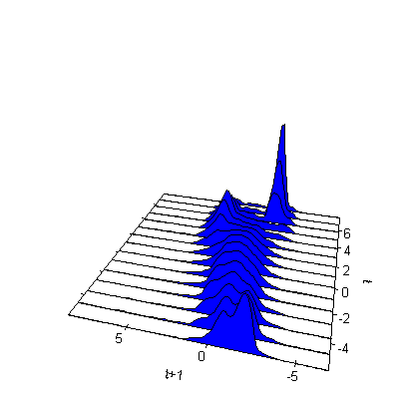 | 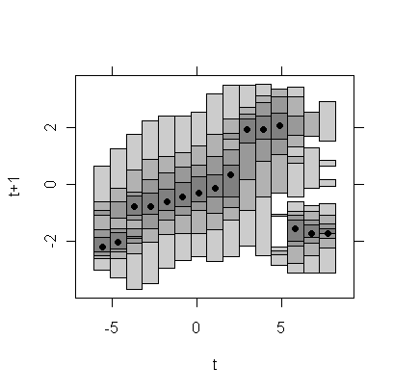
(b) 1.1.1. Bread and Cereals
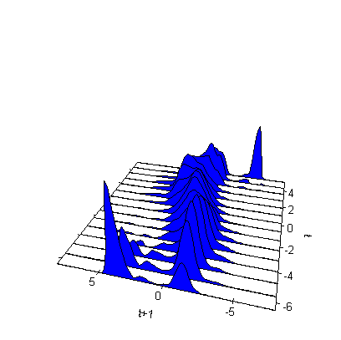 | 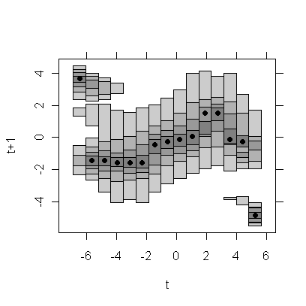

(c) 1.1.2. Meat
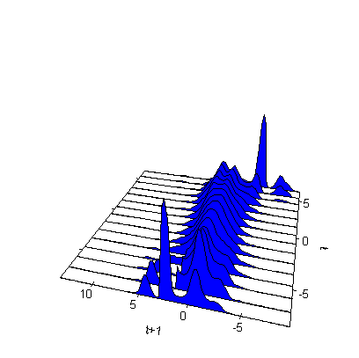 | 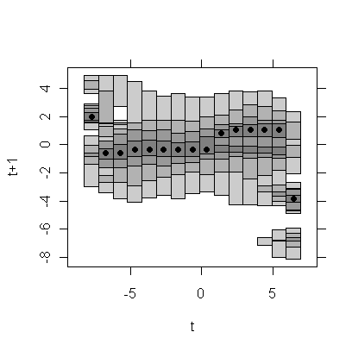
(d) 1.1.3. Fish and seafood
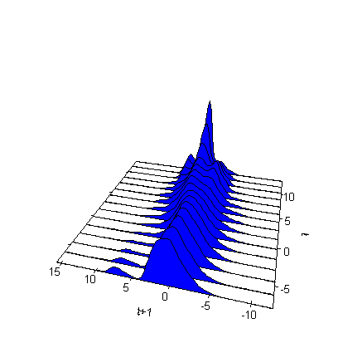 | 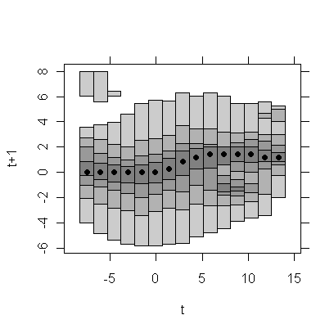
(e) 1.1.4. Milk, cheese and eggs
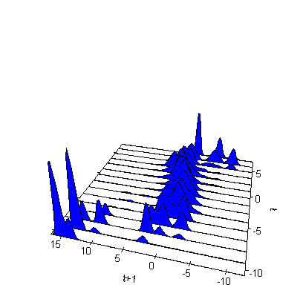 | 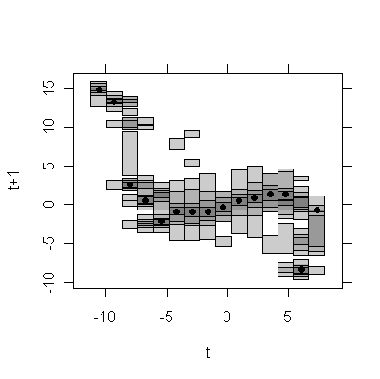
(f) 1.1.5. Oils and fats
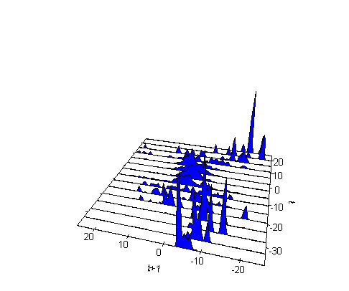 | 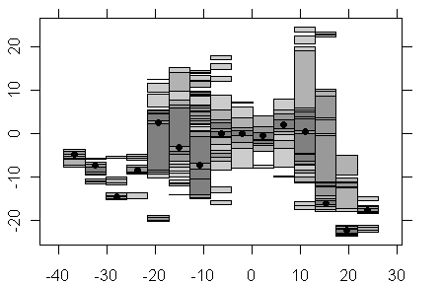
(g) 1.1.6. Fruit
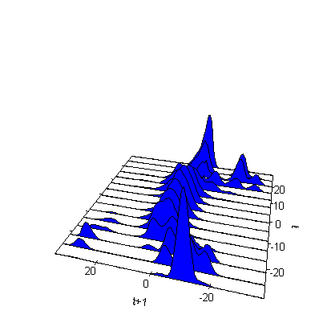 | 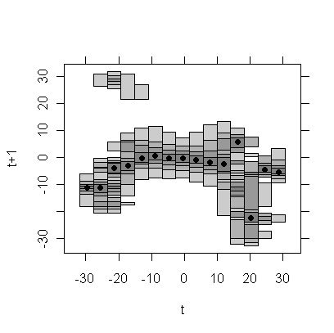

1.1.7. Vegetables
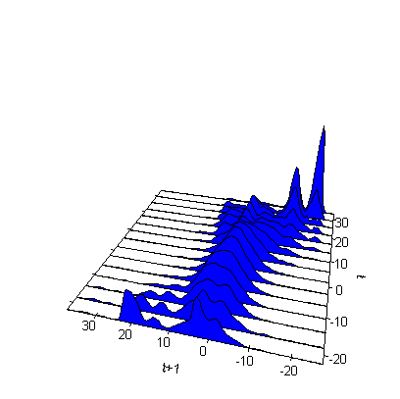 | 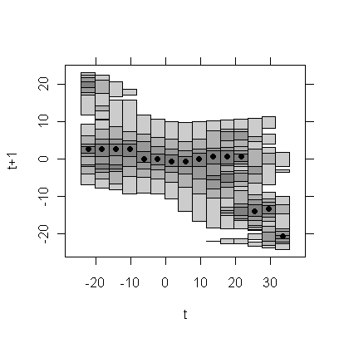
(i) 1.1.8. Sugar, jam, honey, chocolate & confectionery
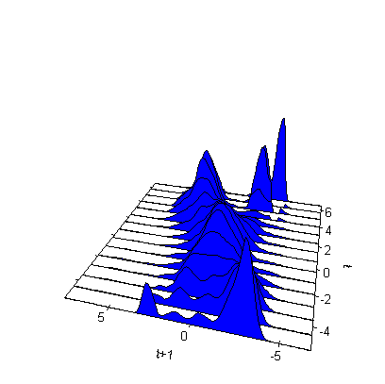 | 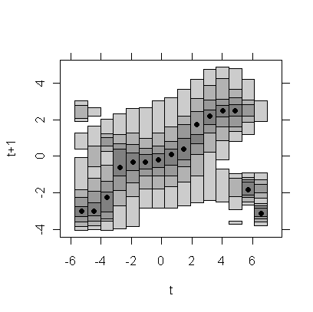
(j) 1.1.9. Food products n.e.c.
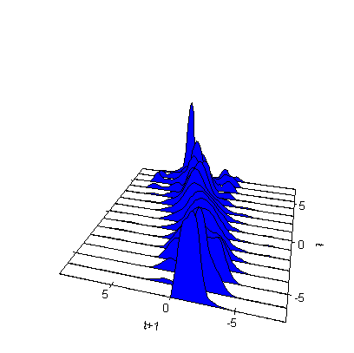 | 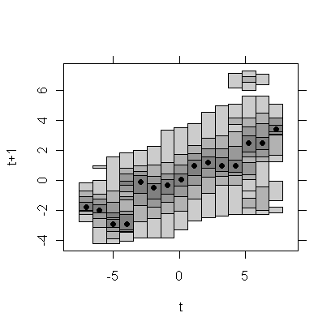
(k) 1.2.1. Coffee, tea and cocoa
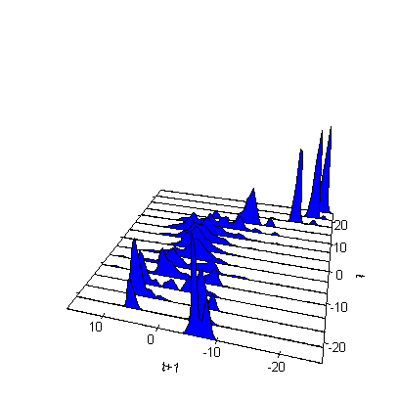 | 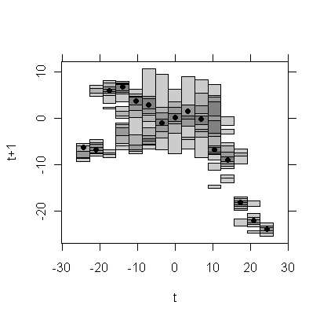
(l) 1.2.2. Mineral water, soft drink, fruit and vegetable juice
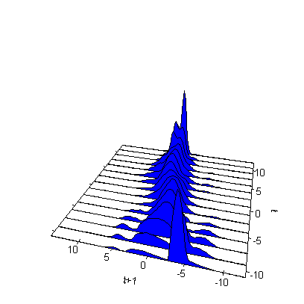 | 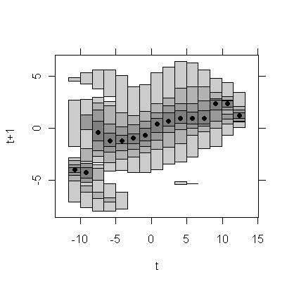

5. Summary of Conclusions
We have investigated the existence of stochastic convergence using parametric methods, and the distribution dynamics of food price inflation rates in the EU. For the latter we used nonparametric methods and an alternative conditional density estimator. Our study considers the cases of both, EMU and non EMU members and in particular the older fifteen member states for which data are available over the period 1997-2009 which is covered with monthly data. The study refers to the whole group of food and non-alcoholic beverages and to eleven product subgroups.
Examination of stochastic convergence as mean reversion, took place for the two equal subperiods 1997-2002 and 2003-2009 as well, in order to find some evidence of non linearities in the convergence process. Our results show that during the whole period there was no mean reversion for the overall food product group and for almost all individual subgroups. The situation appears different for the two sub-periods. During the first, there is strong evidence of stochastic convergence for the overall group and for almost all product subgroups either with both or one of the two lag-selection methods used. During the second, there is no mean reverting behavior for the overall group but there is, for two subgroups of products with both lag selection methods.
In addition to the panel unit root tests applied, half lives for the overall and individual products were estimated. The lack of stochastic convergence for the whole period is consistent with the finding of σ-divergence which as a general rule prevails. In addition, leapfrogging and changing rankings take place. The different findings of econometric analysis and the often changing behavior of standard distributions indicate the existence of strong non linearities in the convergence process. The latter supports the use of non parametric methods to examine the existence of convergence.
The application of nonparametric methods and the use of an alternative kernel density estimator with visualizations show clearly that there is no common trend or law of motion for the evolution of inflation rate deviations. The overall group’s distribution is naturally affected by all subgroups and exhibits a behavior between the extremely opposite cases. In general, countries deviating from the mean tend to move backwards to it in a one year period. Hence, unlike the findings of parametric research, a more detailed nonparametric investigation of distributions supports in general the existence of convergence. Multimodalities and threshold effects in several cases were also found.
References
Aldy, J. (2006), ‘Per Capita Carbon Dioxide Emissions: Convergence or Divergence’, Environmental and Resource Economics, 33:533-555.
Altissimo, F., Benigno, P. and Palenzuela, D.R. (2005), ‘Long-run Determinants of Inflation Differentials in a Monetary Union’, CEPR Discussion Papers, No. 5149.
Arbia G., Basile, R. and Piras G. (2005), Analyzing Intra-Distribution Dynamics. A reappraisal, REAL Discusiion Papers 05-T-11, University of Illinois.
Barro, R. and Sala-i-Martin, X. (1991), ‘Convergence across states and regions’, Brooklin Paper on Economic Activity, 1, 107-82.
Barro, R. J. and Sala-i Martin, X. X. (1992), ‘Convergence’, Journal of Political Economy, 100(2), 223-251.
Basile, R. (2006), Intra-distribution dynamics of regional per capita income in Europe: Evidence from alternative conditional density estimators, 53rd North-American Meetings of the RSAI, November 2006, Toronto.
Beck, G. W., Hubrich, K., and Marcellino, M. (2006), ‘Regional Inflation Dynamics Within and Across Euro Area Countries and a Comparison with the US’, ECB Working Paper No. 681, ECB, Frankfurt.
Birckenbach, F. and Bode, E. (2003), ‘Evaluating the Markov Property in Studies of Economic Convergence’, International Regional Science Review, Vol. 26(3), pp. 363-392.
Borio, C. and Filardo, A. (2007), Globalisation and inflation: New cross-country evidence on the global determinants of domestic inflation, Bank for International Settlements, Monetary and Economic Department, Working Paper, No 227.
Boschi, M. and Girardi, A. (2007), ‘Euro area inflation: long-run determinants and short-run dynamics’, Applied Financial Economics, Vol. 17, pp. 19 – 24.
Bukeviciute, Dierx, L. and Ilzkovi, F. (2009), ‘The functioning of the food supply chain and its effect on food prices in the European Union’, European Commission Occasional Papers 47| May.
Busetti, F., Fabiani, S., and Harvey, A. (2006), ‘Convergence of Prices and Rates of Inflation’, Oxford Bulletin of Economics and Statistics, Vol.68, pp. 863-877.
Busetti, F., Forni, L., Harvey, A. and Venditti, F. (2007), ‘Inflation Convergence and Divergence within the European Monetary Union’, International Journal of Central Banking, Vol. 3(2), pp. 95-121.
Canzoneri M., Cumby, R., Diba, B., Eudey, G. (2002), ‘Productivity trends in Europe: implications for real exchange rates, real interest rates and inflation’, Review of International Economics 10(3), pp.497–516.
Cecchetti, S.G., Mark, N.C., and Sonora, R.J. (2002), ‘Price index convergence among united states cities’, International Economic Review, Vol. 43, pp. 1081-1099.
Coricelli, F., Horvith, R. (2010): ‘Price Setting and Market Structure: An Empirical Analysis of Micro Data in Slovakia’, Managerial and Decision Economics, 31(2-3): 209-233.
Dalsgaard, T. (2008), ‘Produt Market Competition in Slovenia - stylized facts and policy challenges’, International Monetary Fund, www.bsi.si/library/includes/datoteka.asp?DatotekaId=3044
Dayanandan, A., Ralhan, M. (2005), Price Index Convergence Among Provinces and Cities Across Canada: 1978 - 2001, Econometrics Working Paper EWP0504, University of Victoria, Canada.
Durlauf, S. N. and Quah, D. (1999), ‘The new empirics of economic growth’, In Taylor, J. B. and Woodford, M., editors, Handbook of Macroeconomics, Vol. 1, pp. 231-304, North Holland.
Durlauf, S.N., Johnson, P.A. and Temple, J.R.W. (2005), ‘Growth Econometrics’, In Handbook of Economic Growth, Vol. 1A, Aghion P., Durlauf SN (eds). North-Holland, Amsterdam
Erber, G. and Hagemann, H. (2009), Monetary Policy Challenges of the ECB Facing a Divergent Inflationary Process in the EMU Area, in Macroeconomic, Finance and Money: Essays in Honour Of Philip Arestis, Fontana G., McCombie J. and Sawyer M., eds., Palgrave.
Fan, S. C. & Wei, X. (2006), ‘Price Index Convergence in China’, LIngman Universaity, WP 05.
Fousekis, P. (2008), ‘Price Convergence in the EU Poultry and Eggs Market’, Economics Bulletin, Vol. 3, pp. 1-11.
Goldberg, P.K., Verboven, F. (2005), ‘Market integration and convergence to the law of one price: Evidence from the European car market’, Journal of International Economics, Vol. 65, pp. 49-73.
Hyndman, R.J., Bashtannyk, D.M. and Grunwald, G.K. (1996), ‘Estimating and Visualizing Conditional Densities’, Journal of Computational and Graphical Statistics, Vol. 5 (4), pp. 315-336.
Hyndman, R.J. and Yao, Q. (2002), ‘Nonparametric Estimation and Symmetry Tests for Conditional Density Functions’, Journal of Nonparametric Statistics, Vol. 14 (3), pp. 259-278.
Im, K.S., Pesaran, M.H. and Shin Y. (1997), Testing for unit roots in heterogeneous panels, Manuscript, Trinity College, Cambridge.
Kutan, A.M. and Yigit, T.M. (2005), ‘Real and Nominal Stochastic Convergence: Are the New EU members Ready to Join the Euro Zone? ‘, Journal of Comparative Economics, Vol. 33(2), pp.387-400.
Lee, H.Y and Wu, J.L (2001), ‘Mean reversion of inflation rates: evidence from 13 OECD countries’, Journal of Macroeconomics, Vol. 23, pp. 477-487.
Levin, A. and Lin, C.F. (1992), Unit root tests in panel data: Asymptotic and finite sample properties. University of California - San Diego Discussion Paper No. 92-93.
Levin, A., Lin, C. F., and Chu, C. (2002), ‘Unit root tests in panel data: asymptotic and finite sample properties’, Journal of Econometrics, Vol. 108, pp. 1-24.
Li, Q. and Racine, J.S. (2007), Nonparametric Econometrics: Theory and Practice, Princeton University Press, Princeton and Oxford.
Lopez, C. and Papell, D.H. (2010), Testing for Group-Wise Convergence with an Application to Euro Area Inflation, MPRA Paper No. 20585.
Magrini, S. (2007), Analysing Convergence through the Distribution Dynamics Approach: Why and How?, Department of Economics, Ca' Foscari University of Venice, Working Paper No.13/WP/2007.
Mentz, M. and Sebastian, S.P. (2003) ‘Inflation convergence after the introduction of the euro’. CFS Working Paper 2003/30, Center for Financial Sudies an der Johann Wolfgang Goethe-Universität.
Montuenga-Gomez and Victor M. (2002), ‘Did the EMS Encourage Inflation Convergence? ‘ International Advances in Economic Research, Vol. 8(2), pp.119-127.
Nickell, S.J. (1981), ‘Biases in dynamic models with fixed effects’, Econometrica, Vol.49, pp. 1417–1426.
Pesaran, M.H. Smith, R.P.,Yamagata, T.. and Hvozdyk L. (2009), ‘Pairwise tests of purchasing power parity’, Econometric Reviews, Vol. 28(6), pp. 495-521.
Quah, D.T. (1993), ‘Empirical Cross-section Dynamics in Economic Growth’, European Economic Review, Vol. 37 (2-3), pp.426-434.
Quah, D.T (1996), ‘Empirics for economic growth and convergence’, European Economic Review, Vol.40, pp. 1353-1375.
Quah, D.T (1997), ‘Empirics for growth and distribution: stratification, polarization, and convergence clubs’, Journal of Economic Growth, Vol. 2, pp. 27-59.
Reichlin, L., (1999), Discussion of 'Convergence as Distribution Dynamics', by Danny Quah, in Market Integration, Regionalism, and the Global Economy, R. Baldwin, D. Cohen, A. Sapir, and A. Venables, eds., Cambridge, Cambridge University Press.
Roberts, J.M. (2006), ‘Monetary Policy and Inflation Dynamics’, International Journal of Central Banking, 2:193-230.
Rogers, J. H. (2001), ‘Price Level Convergence, Relative Prices, and Inflation in Europe’, FRB International Finance Discussion Paper No. 699.
Rosenblatt, M. (1969), Conditional probability density and regression estimators. In: Krishnaiah, P.R. (Ed.), Multivariate Analysis II, Academic Press, New York, pp. 25-31.
Sala-i-Martin, X. (1996), ‘Regional Cohesion: Evidence and Theories of Regional Growth and Convergence’, European Economic Review, Vol. 40 (6), pp.1325-1352.
Sarno, E. and Zazzaro, A., (2003), Structural Convergence of Macroeconomic Time Series: Evidence for Inflation Rates in EU Countries, Working Papers 180, Universita' Politecnica delle Marche (I), Dipartimento di Economia
Silverman, B.W. (1986), Density Estimation for Statistics and Data Analysis, Chapman and Hall, London.
Sturm, J.E., Fritche, U., Graff, M., Lamla, M., Lein, S., Nitch, V., Liechti, D. and Triet, D. (2009), ‘The euro and prices: changeover-related inflation and price convergence in the euro area’, European economy, Economic papers 381|June.
Taylor, A. M. (2001), ‘Potential pitfalls for the purchasing-power-parity puzzle? Sampling and specification biases in mean-reversion tests of the law of one price’, Econometrica, 69, pp. 473-498.
Weber, A.A. and Beck, G. W. (2005), Price stability, inflation convergence and diversity in EMU: Does one size fit all?, Manuscript, Goethe University, Frankfurt.
Yilmazkuday, H. (2009), Inflation Targeting and Inflation Convergence within Turkey’, MPRA Paper No. 16770.

The half-live is the time necessary to fill half of the transition between the initial level and the stationary value.
Using the example of a sport league, it presents β-convergence in terms of how rapidly teams at the bottom of the ranking tend to rebound towards the middle, or equivalently, how quickly champions tends to revert to mediocrity.
For a relevant review on time series and panel data analyses, see Durlauf et al. (2005).
Nichell’s formula for the estimation of the adjustedis:, where , and .
A process is said to be a Markov chain if the random variable at time t+τ depends exclusively on the information set at time t and not on any other previous period in time.
Mean square error is the sum of the variance and the square of the bias. Because it is a point-wise property, we are interesting in minimizing integrated mean square error (Li and Racine, 2007)

