AUA Working Paper Series No. 2009-11

Utility-derived Supply Function of Sheep Milk: The Case of Etoloakarnania, Greece

Stelios Rozakis
Department of Agricultural Economics and Rural Development
Agricultural University of Athens
rozakis@aua.gr

Alexandra Sintori
Department of Agricultural Economics and Rural Development
Agricultural University of Athens
al_sintori@yahoo.gr

Konstantinos Tsiboukas
Department of Agricultural Economics and Rural Development
Agricultural University of Athens
tsiboukas@aua.gr

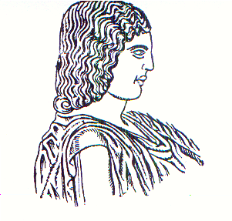
Agricultural University of Athens ∙
Department of Agricultural Economics
& Rural Development ∙ http://www.aoa.aua.gr

